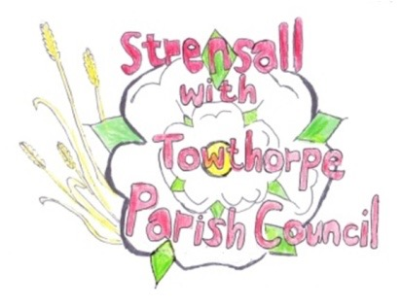 **STRENSALL WITH TOWTHORPE PARISH COUNCIL** The Village Hall, Northfields, Strensall, York YO325XW e-mail: [strensalltowthorpePC@outlook.com](mailto:strensalltowthorpePC@outlook.com) phone: 01904 491569

**MINUTES OF A PLANNING COMMITTEE MEETING HELD ON TUESDAY 23rd JULY 2024 AT 6.30PM**

**Councillors Present:** Andrew Bolton Chris Chambers Tony Fisher Graham Green

**In Attendance:** Fiona Hill - Parish Clerk

**Public Present:** 0

1. **a) To receive apologies for absence given in advance of the meeting:** None

**b) To consider the approval of reasons given for absence:** N/A

1. **To receive any declarations of interest under the Parish Council Code of Conduct or**

**Members register of interests:** None

1. **To approve the minutes of the Planning Committee meeting of 25th June 2024 and 09th July 2024:**

Resolved / Approved (Unanimous)

1. **To discuss any ongoing issues and information received:** None

**23/124 To consider and respond to consultations from City of York Council to the planning a applications as follows:** a) 24/01231/TCA – Fell 1 no. (dying) Silver Birch – tree in a conservation area @

1. The Village

Resolved / No Objection, subject to guidance from City of York Council Tree Officer (Unanimous)

**23/125 To note planning decisions received:** None

**23/126 To confirm date of the next meeting on Tuesday 13th August 2024 @ 6.30 p.m.** Resolved / Approved (Unanimous)