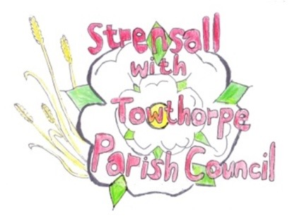 **STRENSALL WITH TOWTHORPE PARISH COUNCIL** The Village Hall, Northfields, Strensall, York YO325XW e-mail: [strensalltowthorpePC@outlook.com](mailto:strensalltowthorpePC@outlook.com) phone: 01904 491569

**MINUTES OF A PLANNING COMMITTEE MEETING HELD ON TUESDAY 25th JUNE 2024 AT 6.30PM**

**Councillors Present:** Andrew Bolton Chris Chambers Tony Fisher Graham Green

**In Attendance:** Fiona Hill - Parish Clerk

**Public Present:** 0

1. **a) To receive apologies for absence given in advance of the meeting:** Lawrence Mattinson

**b) To consider the approval of reasons given for absence:** Resolved / Approved (Unanimous)

1. **To receive any declarations of interest under the Parish Council Code of Conduct or**

**Members register of interests:** Cllr Chambers, 24/01073/TCA, Maintenance team member

Cllr Fisher, 24/00325/FULM, CYC Planning committee member

1. **To approve the minutes of the Planning Committee meeting of 28th May 2024:**

(Meeting on 11th June Cancelled)

Resolved / Approved (Unanimous)

1. **To discuss any ongoing issues and information received:**
2. Network Rail - Construction of two-platform railway station including footbridge, lift towers, staircases, car park, bus turning circle, cycle parking, new foot/cycle path to west of railway and Towthorpe Road and associated works @ Land Adjacent Rail Line At Towthorpe Road (24/00325/FULM)

The committee would study the documents on the planning portal and Cllr Bolton would draft response, then a final response would be agreed at the next meeting.

**23/117 To consider and respond to consultations from City of York Council to the planning a applications as follows:**

a) 24/00942/FUL - Single storey rear extension @ 5 Shelley Drive

Resolved / No Objections (Unanimous)

1. 24/01044/FUL - Two storey side and rear extension after removal of garage @ 6 Kirklands

Resolved / No Objections (Unanimous)

1. 24/01073/TCA - Crown raising up to 5.2m of G32 over car park, and pruning back of T20 Cherry, T23 Lime and T26 Sycamore from roadside 2-3m, felling of declining Ash saplings in G30, felling of T11 Almond (if it does not recover in 2024) and remove failed limb of T1 Ash - trees in a conservation area @ St Marys Church Church Lane

Resolved / No Objections, subject to approval of the City of York Council Tree Officer (Unanimous)

1. **To note planning decisions received:**

* 24/00596/FUL - Single storey side and rear extensions following demolition of existing conservatory @ 14 Barley Rise - Approved
* 24/00696/FUL - First floor juliet balcony to rear and single storey rear extension following demolition of existing conservatory @ 22 Westpit Lane – Approved
* 24/00848/CPD - Proposed development of a single storey rear extension @ 31 Fossview Close - Refused

1. **To confirm date of the next meeting on Tuesday 09th July 2024 @ 6.30 p.m.**

Resolved / Approved (Unanimous)