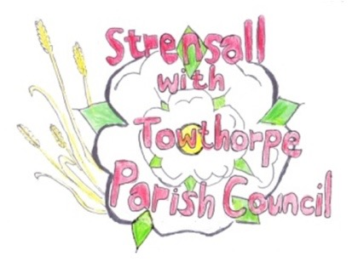 **STRENSALL WITH TOWTHORPE PARISH COUNCIL** The Village Hall, Northfields, Strensall, York YO325XW e-mail: [strensalltowthorpePC@outlook.com](mailto:strensalltowthorpePC@outlook.com) phone: 01904 491569

**MINUTES OF A PLANNING COMMITTEE MEETING HELD ON TUESDAY 27rd AUGUST 2024 AT 6.30PM**

**Councillors Present:** Andrew Bolton Chris Chambers Tony Fisher Graham Green Lawrence Mattinson

**In Attendance:** Fiona Hill - Parish Clerk

**Public Present:** 0

1. **a) To receive apologies for absence given in advance of the meeting:** Cllr Tetley

**b) To consider the approval of reasons given for absence:** Resolved / Approved (Unanimous)

1. **To receive any declarations of interest under the Parish Council Code of Conduct or**

**Members register of interests:** None

1. **To approve the minutes of the Planning Committee meeting of 23rd July 2024:**

Resolved / Approved (Unanimous)

1. **To discuss any ongoing issues and information received:** None
2. **To consider and respond to consultations from City of York Council to the planning a applications as follows:**

a) 24/01404/FUL - Single storey rear extension @ 17 Portisham Place

Resolved / No Objections (Unanimous)

b) 24/01453/FUL - Single storey side extension @ 7 Renfrew Green

Resolved / No Objections (Unanimous)

**23/139 To note planning decisions received:**

1. 24/00905/FUL - Single storey side extension @ Greensleeves Lords Moor Lane - Approved
2. 24/01073/TCA - Crown raising up to 5.2m of G32 over car park, and pruning back of T20 Cherry, T23 Lime and T26 Sycamore from roadside 2-3m, felling of declining Ash saplings in G30, felling of T11 Almond (if it does not recover in 2024) and remove failed limb of T1 Ash - trees in a conservation area @ St Marys Church Church Lane – Consented
3. 24/01092/FUL - Variation of condition 2 of permitted application 23/02141/FUL to alter depth of the extension @ 8 Oak Tree Way – Approved
4. 24/01100/FUL - Single storey rear extension, new pitched roof to side garage, partial conversion of garage to habitable space and raised patio to rear @ 88 The Village – Approved
5. 24/01119/FUL - 3no. rooflights to front and rear roofslopes @ 4 Redmayne Square - Approved
6. 24/01231/TCA - Fell 1no. (dying) Silver Birch - tree in a conservation area @ 69 The Village – Consented

**23/140 To confirm date of the next meeting on Tuesday 10th September 2024 @ 6.30 p.m.** Resolved / Approved (Unanimous)