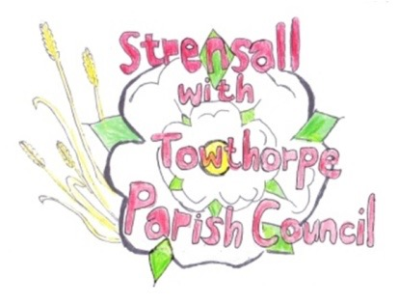**STRENSALL WITH TOWTHORPE PARISH COUNCIL**

The Village Hall, Northfields, Strensall, York YO325XW

e-mail: [strensalltowthorpePC@outlook.com](mailto:strensalltowthorpePC@outlook.com) phone: 01904 491569

NOTICE is hereby given that there will be a Planning Committee meeting of The Parish Council Planning Committee on Tuesday 10th September 2024 at 6.30pm to be held in the Village Hall for the purpose of transacting the business shown on the Agenda below.

Members of the public and press are welcome to attend

Members of the Council are hereby summoned to attend

**AGENDA**

1. a) To receive apologies for absence given in advance of the meeting:

b) To consider the approval of reasons given for absence:

2. To receive any declarations of interest under the Parish Council Code of Conduct and Register of Interests

3. To approve the Minutes of 27th August 2024

4. To discuss any ongoing issues and information received:

5. To consider and respond to consultations from City of York Council to the planning applications as follows:

1. 24/00507/FUL - Partial change of use to hair salon (use class E) – retrospective @ 16 Cumbrian Avenue
2. 24/01526/TCA - Fell 1no. Lawson Cypress (rear gdn); fell 1no. Yew and 1no. Spruce (front gdn) - trees in a conservation area @ The Vicarage, 10 York Road
3. 24/01538/FUL - Single storey rear extension following demolition of conservatory and porch to front @ The Swallows, 23 Chatsworth Avenue
4. 24/01558/FUL - Two storey side extension, single storey rear extension and enlarged dormers to front and rear roofslopes @ 6 Kirklands

6. To note planning decisions received:

7. To confirm the date of the next meeting: - 24th September 2024 at **6.30pm**

**Fiona Hill** - Clerk to the Parish Council 04th September 2024