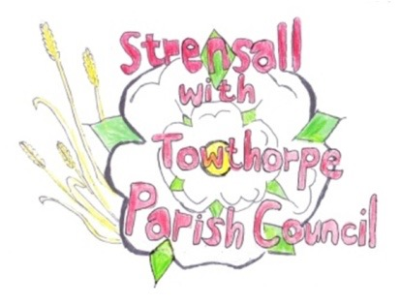**STRENSALL WITH TOWTHORPE PARISH COUNCIL**

The Village Hall, Northfields, Strensall, York YO325XW

e-mail: [strensalltowthorpePC@outlook.com](mailto:strensalltowthorpePC@outlook.com) phone: 01904 491569

NOTICE is hereby given that there will be a Planning Committee meeting of The Parish Council Planning Committee on Tuesday 08th October 2024 at 6.30pm to be held in the Village Hall for the purpose of transacting the business shown on the Agenda below.

Members of the public and press are welcome to attend

Members of the Council are hereby summoned to attend

**AGENDA**

1. a) To receive apologies for absence given in advance of the meeting:

b) To consider the approval of reasons given for absence:

2. To receive any declarations of interest under the Parish Council Code of Conduct and Register of Interests

3. To approve the Minutes of 24th September 2024

4. To discuss any ongoing issues and information received:

5. To consider and respond to consultations from City of York Council to the planning applications as follows:

1. 24/01591/FUL - Single storey front extension, replacement roof to rear projection and 1no. window to side @ Dairy Cottage, Towthorpe Road
2. 24/01670/FUL - Erection of 1no. dwelling (use class C3) to rear with associated access/landscaping and replacement double detached garage to main dwelling @ Gorse Cottage, Lords Moor Lane
3. 24/01724/TCA - Crown reduce 1no. Hawthorn Tree up to 3.6m (T1); Crown reduce up to 1.8 meters and dead wood removal from 1no. Apple (T2) ; Crown reduce up to 1.8 meters 1no. Plum (T3); General prune to encourage fruit production and for maintenance of 1no. Apple (T4); Up to 2.4m reduction of 1no. Ash tree (T5); Crown reduction up to 2.4m of 1no. Wild Cherry (T6); Reduction of Leylandii Hedge (G1) - trees in a conservation area @ 113 The Village
4. 24/01725/TCA - Reduce 2no. Plum trees (T7, T8)  up to 2.4m to formalise and contain growth - trees in a conservation area @ 115 The Village

6. To note planning decisions received:

7. To confirm the date of the next meeting: - 22th October 2024 at **6.30pm**

**Fiona Hill** - Clerk to the Parish Council 02th October 2024