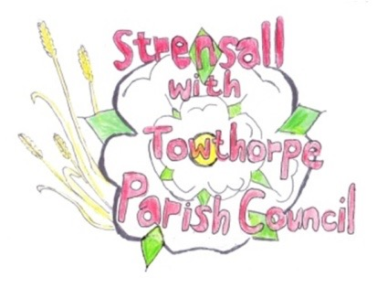**STRENSALL WITH TOWTHORPE PARISH COUNCIL**

The Village Hall, Northfields, Strensall, York YO325XW

e-mail: [strensalltowthorpePC@outlook.com](mailto:strensalltowthorpePC@outlook.com)

phone: 01904 491569

Chairman : Mr A H Fisher

**MINUTES OF AN PARISH COUNCIL MEETING HELD IN THE VILLAGE HALL ON TUESDAY 10th SEPTEMBER 2024 AT 7.00 PM**

**Councillors Present:** Andrew Bolton Chris Chambers Tony Fisher1 Graham Green Alan May Susan Nunn John Shirbon

**In Attendance:** Fiona Hill – Parish Clerk

**Public Present:** 0

1 City of York Councillor

Cllr Fisher was asked to approach Cllr Healey and ask him to attend a future meeting, as the Parish Council would like to see both Ward Councillors more regularly.

1. **a) To receive apologies for absence given in advance of the meeting:**  Cllr Pillai **b) To consider the approval of reasons given for absence:** Resolved / Approved (Unanimous)
2. **To discuss the ordinary and casual vacancies** (Currently four)**:** Nothing to report
3. **To receive any declarations of interest under the Parish Council Code of Conduct or**

**Members register of interests:** None

1. **a) To approve the minutes of the Parish Council meeting of 09th July 2024:**

Resolved / Approved (Unanimous)

**b) To endorse the approved Planning Committee minutes of 09th July, 23rd July and 27th August 2024:**

Resolved / Endorsed (Unanimous)

1. **Public participation on any subject relating to the agenda:** None

**24/156 To receive matters raised by/with City of York Ward Councillors:** Cllr Fisher had advised that there are a number of road closures around the village and planned in the near future. Due to the change of government, the funding is uncertain for the Haxby Station and the ringroad. Land along Brecks Lane had been tidied and he would keep a watching brief to advise if a planning application is submitted. Due to Government changes to the NPPF, the Local Plan, if adopted, will immediately be subject to review.

**24/157 To discuss and, if necessary, agree action on matters arising/ongoing issues:** a)North Yorkshire Police monthly reports – Cllrs noted receipt of the July and August 2024 reports. Cllr Fisher reported that plants had been removed from planters, but he had replaced them and a solen iPad had been found, via its tracker, on Northfields.

b) Memorial Tree Planting Policy

If a person has served on the Parish Council for a minimum of ten years and died in post, the Parish Council will fund a tree in memory of the person. If a person has served on the Parish Council for a minimum of ten years and retired, the family can fund a tree in memory of the person. The Parish Council will, after discussion with the family, will make the final decision regarding the venue, position and maintenance. The Parish Council will, after discussion with the family, will make the final decision regarding the design and wording of the plaque. Resolved / Adopted (Unanimous)

The Parish Council would draft a policy for non Councillors.

c) York Road Garden – Governance, Future Planting Cllr Shirbon circulated a drawing his vision for the area and the Parish Council had now had sight of the emails to/from David Meigh, CYC. 1. Current arrangements are working fine but on an annual renewal basis. They could terminated at any future anniversary. 2. Leasing the area with a 40 year lease is an alternative that can be perused. This would incur a small, so called peppercorn rent and would give 40 years security. 3. There is another possible option which emulates Acomb Green whereby ownership of the garden land would be assigned to the Parish Council. In addition, the Highways Department will need to be consulted about the grass verges in front of the garden. Resolved / The Parish Council would request a draft of the legal document for both leasing and transferring ownership of the land from CYC to the Parish Council, as there were concerns about the main drain within the area (Unanimous) Resolved / The Parish Council would contact Highways to apply for a license to site two planters on the adjacent verge.

d) Wild Flower area – Kirklands At a previous meeting it was agreed that the resident, who lives next door to this area, could cultivate a wildflower area. However, due to a misunderstanding, this has not proceeded. The area is getting unsightly, but it should be noted that access is difficult without crossing land not owned by the PC. Cllrs Fisher and Shirbon would visit the area and report back to the Parish Council at the next meeting.

**24/158 To discuss and, if necessary, agree action, on matters raised since last meetings:**

1. Purchase of bulbs

Resolved / The Parish Council would spend up to £120.00, which Cllr Nunn would purchase. (Unanimous) Resolved / The Parish Council agreed that the planters would remain empty over winter.

1. Remembrance Sunday arrangements Community TM Limited were taking charge of the road closure details again this year. Hopefully Cllrs Fisher and Pillai would act an volunteers, again as per last year.

Cllr Chambers would lay the Parish Council wreath.

1. Cemetery – Review of fees Resolved / The rates would be increased by 20% on 01 January 2025, then by 20% every five years going forward.
2. Play Area Inspections – the Parish Clerk reminded Parish Councillors that inspections were now weekly, needed doing and reports were required. Weekly reminders would be sent to Cllrs. ROSPA – Play Safety will conduct this in September 2024 and a report will follow.

**24/159 To discuss and, if necessary, agree action, on any correspondence received:** a)Defence Infrastructure Organisation – car park closure policy Major (Retired) PM Ennis, Training Safety Officer, Defence Infrastructure Organisation, UK Defence Training Estate – North emailed (03Aug24) as follows: “I hope you are enjoying the Bank Holiday, we have had discussions with our Regional Headquarters regarding the two permissive car parks on the military training area at Strensall. I have spoken previously with Tony (Chairman of the Parish Council) about the problems we are experiencing with the unsociable and illegal activity that takes place in the car parks during the evening and nighttime when the site has closed for the working day. I am proposing that we close the two car parks at 1600 Hrs when the range staff routinely close down the site prior to finishing work. I suggest that we start this policy during the Autumn and Winter months when the days become shorter, and the vast majority of visitor's have been and walked their pets during daylight. I would appreciate it if the Chairman could support this new policy and would respectfully him to drop me an email highlighting his concerns with the unsavoury activity that takes place in the two car parks after dark. Can I thank you for your support in advance”. Resolved - The Parish Council supports this policy for autumn/winter, but would urge a review for spring/summer, when hopefully longer hours of opening could be accommodated”. (Unanimous)

b) City of York Council – Joint Standards Committee – election of one parish representation The Parish Council noted that Cllr Chambers is a Parish Council representative and Cllr Fisher is a City of York Council representative on this committee. No other Parish Councillors wished to join the committee.

**24/160 To discuss matters raised by/with Parish Clerk/Responsible Financial Officer (RFO):** a) Bank reconciliation, income received, payments made to date:

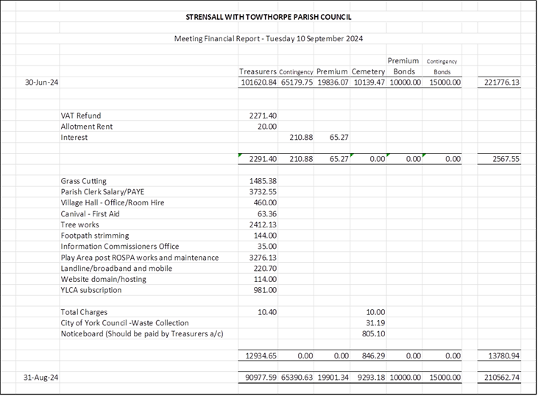

b) Payment Approval: None

c) Internal Controls Checks: A budget review for 2024/2025 and a draft budget for 2025/2026 will be prepared for the next meeting.

d) Yorkshire Local Councils Association: Nothing to report

e) Monthly Report from Parish Office – Nothing to report

**24/161 To confirm the date of the next meeting as Tuesday 08th October 2024 @ 7.00 p.m.:** Resolved / Approved (Unanimous)