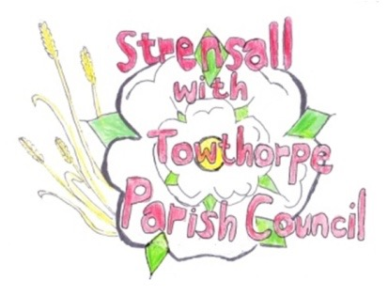 **STRENSALL WITH TOWTHORPE PARISH COUNCIL** The Village Hall, Northfields, Strensall, York YO325XW e-mail: [strensalltowthorpePC@outlook.com](mailto:strensalltowthorpePC@outlook.com) phone: 01904 491569

**MINUTES OF A PLANNING COMMITTEE MEETING**

**HELD ON TUESDAY 24th SEPTEMBER 2024 AT 6.30PM**

**Councillors Present:** Andrew Bolton Chris Chambers Tony Fisher Graham Green

**In Attendance:** Fiona Hill - Parish Clerk

**Public Present:** 0

1. **a) To receive apologies for absence given in advance of the meeting:** Cllr L Mattinson

**b) To consider the approval of reasons given for absence:** Resolved / Approved (Unanimous)

1. **To receive any declarations of interest under the Parish Council Code of Conduct or**

**Members register of interests:** None

1. **To approve the minutes of the Planning Committee meeting of 10th September 2024:**

Resolved / Approved (Unanimous)

1. **To discuss any ongoing issues and information received:** Cllr Fisher gave an update on the City of York Council Local Plan
2. **To consider and respond to consultations from City of York Council to the planning a applications as follows:**
3. 24/01577/FUL – Two storey side and single storey rear extensions following demolition of existing garage and conservatory @ 39 Riverside Walk

Resolved / No Objection (Unanimous)

1. 24/01590/TCA – 30% crown reduction, crown thin and clean of 1 no. Cherry and 1 no. Apple, formative pruning of 1 no. Crab Apple, and pruning back of branches of 1 no. Tree overhanging from 58 The Village – trees in a conservation area @ 60 The Village

Resolved / No Objection, subject to the supervision of the City of York Council Tree Officer and that the work is done by a qualified tree surgeon (Unanimous)

**23/153 To note planning decisions received:**

1. 24/00645/FUL – Erection of 1 no. two storey dwelling and detached outbuilding for grage and office after demolition of bungalow and garage @ Ivanhoe, 8 West End - Approved

**23/154 To confirm date of the next meeting on Tuesday 08th October 2024 @ 6.30 p.m.** Resolved / Approved (Unanimous)