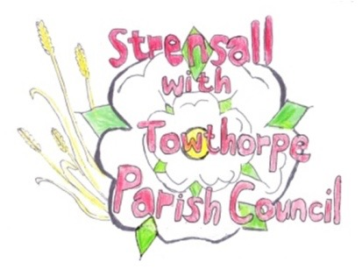 **STRENSALL WITH TOWTHORPE PARISH COUNCIL** The Village Hall, Northfields, Strensall, York YO325XW e-mail: [strensalltowthorpePC@outlook.com](mailto:strensalltowthorpePC@outlook.com) phone: 01904 491569

**MINUTES OF A PLANNING COMMITTEE MEETING**

**HELD ON TUESDAY 08th OCTOBER 2024 AT 6.30PM**

**Councillors Present:** Andrew Bolton Chris Chambers Tony Fisher Graham Green Lawrence Mattinson

**In Attendance:** Fiona Hill - Parish Clerk

**Public Present:** 1

1. **a) To receive apologies for absence given in advance of the meeting:** None

**b) To consider the approval of reasons given for absence:** N/A

1. **To receive any declarations of interest under the Parish Council Code of Conduct or**

**Members register of interests:** None

1. **To approve the minutes of the Planning Committee meeting of 24th September 2024:**

Resolved / Approved (Unanimous)

1. **To discuss any ongoing issues and information received:** None
2. **To consider and respond to consultations from City of York Council to the planning a applications as follows:**
3. 24/01591/FUL - Single storey front extension, replacement roof to rear projection and 1no. window to side @ Dairy Cottage, Towthorpe Road

Resolved / No Objection (Unanimous)

1. 24/01670/FUL - Erection of 1no. dwelling (use class C3) to rear with associated access/landscaping and replacement double detached garage to main dwelling @ Gorse Cottage, Lords Moor Lane

Resolved / Objection, for the reasons following: (Unanimous)

* The development appears to contravene policy DH1 on page twenty-nine of the Strensall with Towthorpe Neighbourhood Plan (Adopted Version).
* The development is within 400 metres of the Strensall Common SAC, where the City of York Council draft Local Plan states developments should be restricted.
* The information regarding the discharge of surface water is ambivalent and there has been significant flooding in this area.
* There does not appear to be permission from Yorkshire Water to discharge into the sewer.

1. 24/01724/TCA - Crown reduce 1no. Hawthorn Tree up to 3.6m (T1); Crown reduce up to 1.8 meters and dead wood removal from 1no. Apple (T2) ; Crown reduce up to 1.8 meters 1no. Plum (T3); General prune to encourage fruit production and for maintenance of 1no. Apple (T4); Up to 2.4m reduction of 1no. Ash tree (T5); Crown reduction up to 2.4m of 1no. Wild Cherry (T6); Reduction of Leylandii Hedge (G1) - trees in a conservation area @ 113 The Village

Resolved / No Objection, subject to guidance from the City of York Council Tree Officer and the work been conducted by a qualified tree surgeon (Unanimous)

1. 24/01725/TCA - Reduce 2no. Plum trees (T7, T8)  up to 2.4m to formalise and contain growth - trees in a conservation area @ 115 The Village

Resolved / No Objection, subject to guidance from the City of York Council Tree Officer and the work been conducted by a qualified tree surgeon (Unanimous)

**23/160 To note planning decisions received:** None

**23/161 To confirm date of the next meeting on Tuesday 22nd October 2024 @ 6.30 p.m.** Resolved / Approved (Unanimous)