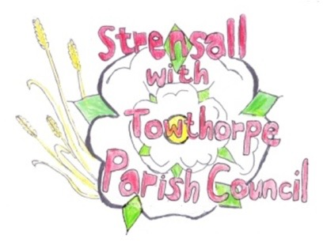 **STRENSALL WITH TOWTHORPE PARISH COUNCIL** The Village Hall, Northfields, Strensall, York YO325XW e-mail: [strensalltowthorpePC@outlook.com](mailto:strensalltowthorpePC@outlook.com) phone: 01904 491569

**MINUTES OF A PLANNING COMMITTEE MEETING**

**HELD ON TUESDAY 12th NOVEMBER 2024 AT 6.30PM**

**Councillors Present:** Andrew Bolton Tony Fisher Graham Green Lawrence Mattinson

**In Attendance:** Fiona Hill - Parish Clerk

**Public Present:** 4

1. **a) To receive apologies for absence given in advance of the meeting:** Chris Chambers

**b) To consider the approval of reasons given for absence:** Resolved / Approved (Unanimous)

1. **To receive any declarations of interest under the Parish Council Code of Conduct or**

**Members register of interests:** None

1. **To approve the minutes of the Planning Committee meeting of 22nd October 2024:**

Resolved / Approved (Unanimous)

1. **To discuss any ongoing issues and information received:**

The Parish Council had received notification of Planning Appeal in respect of Application 24/00204/OUT at Pigotts Autoparts, Sheriff Hutton Road

1. **To consider and respond to consultations from City of York Council to the planning a applications as follows:**

24/01936/TCA – Silvicultural thin of woodland involving the felling of 11no. Norwegian Spruce and 4no. Plum; planting of at least 6 native trees and reestablishment of native hedge on eastern boundary - trees in a conservation area - Land Adjacent The Garth Southfields Road

Resolved / The Parish Council robustly objects to this application as there is no professional arboricultural/Silvicultural report of the trees within a Conservation Area. (Unanimous)

1. **To consider and respond to consultations from City of York Council to the planning a applications as follows:** a) 24/00310/FUL - Erection of an agricultural livestock building with a roofed cover @

Lambshill, Towthorpe Moor Lane

b) 24/01538/FUL - Single storey rear extension following demolition of conservatory and porch to front @ The Swallows, 23 Chatsworth Avenue – Approved

c) 24/01558/FUL - Two storey side extension, single storey rear extension and enlarged dormers to front and rear roofslopes @ 6 Kirklands – Approved

**23/175 To confirm date of the next meeting on Tuesday 26th November 2024 @ 6.30 p.m.** Resolved / Approved (Unanimous)