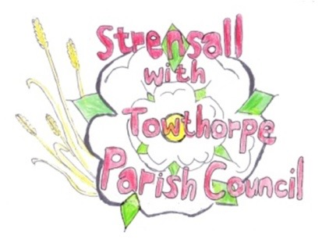**STRENSALL WITH TOWTHORPE PARISH COUNCIL**

The Village Hall, Northfields, Strensall, York YO325XW

e-mail: [strensalltowthorpePC@outlook.com](mailto:strensalltowthorpePC@outlook.com) phone: 01904 491569

NOTICE is hereby given that there will be a Planning Committee meeting of The Parish Council Planning Committee on Tuesday 14th January 2025 at 6.30pm to be held in the Village Hall for the purpose of transacting the business shown on the Agenda below.

Members of the public and press are welcome to attend

Members of the Council are hereby summoned to attend

**AGENDA**

1. a) To receive apologies for absence given in advance of the meeting:

b) To consider the approval of reasons given for absence:

2. To receive any declarations of interest under the Parish Council Code of Conduct and Register of Interests

3. To approve the Minutes of 12th November 2024 (The meeting on 26th November 2024 and 10th December 2024 were cancelled)

4. To discuss any ongoing issues and information received:

5. To consider and respond to consultations from City of York Council to the planning applications as follows:

1. 24/02241/FUL - Construction of 7no. Fishers bedroom lodges, separate shower block with combined office, formation of vehicle access and installation of 10no. car parking spaces @ Potteries Lake, Pottery Lane

6. To note planning decisions received:

1. 24/01693/TCA - Fell 2no. (diseased) Alders and remove deadwood from 2no. Alders - trees in a conservation area @ Tree Tops 1B The Village Strensall - Consented
2. 24/01724/TCA - Crown reduce 1no. Hawthorn Tree up to 3.6m (T1); Crown reduce up to 1.8 meters and dead wood removal from 1no. Apple (T2) ; Crown reduce up to 1.8 meters 1no. Plum (T3); General prune to encourage fruit production and for maintenance of 1no. Apple (T4); Up to 2.4m reduction of 1no. Ash tree (T5); Crown reduction up to 2.4m of 1no. Wild Cherry (T6); Reduction of Leylandii Hedge (G1) - trees in a conservation area @ 113 The Village Strensall - Consented
3. 24/01725/TCA - Reduce 2no. Plum trees (T7, T8) up to 2.4m to formalise and contain growth - trees in a conservation area @ 115 The Village Strensall – Consented
4. 24/01798/TCA - 2.4m crown reduction and up to 1.8m lateral reduction of 1no. Crab Apple - tree in a conservation area @ 16 The Village – Consented
5. 24/01806/TCA - Crown reduce 1no. Ash 2.4m in height and 1.8m laterally and cut back branches of fruit trees (TG1) that overhang 123 The Village - trees in a conservation area @ 125 The Village – Consented
6. 24/01936/TCA - Silvicultural thin of woodland involving the felling of 11no. Norwegian Spruce (of which four are already dead) and plant at least 6 native trees and reestablish native hedge on eastern boundary - trees in a conservation area @ Land Adjacent The Garth, Southfields Road – No Objections

7. To confirm the date of the next meeting: - 28th January 2025 at **6.30pm**

**Fiona Hill** - Clerk to the Parish Council 08th January 2025