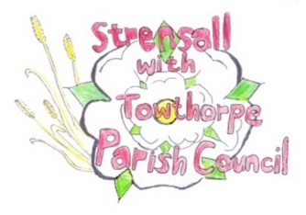 **Strensall with Towthorpe Parish Council**

The Village Hall, Northfields, Strensall, YORK, YO32 5XN.

Tel: 01904 491569 Email: [strensalltowthorpepc@outlook.com](mailto:strensalltowthorpepc@outlook.com) Chairman Councillor T Fisher

NOTICE is hereby given that there will be a meeting of The Parish Council on **Tuesday 14th January 2025 at 7.00 p.m.** to be held in the Village Hall for the purpose of transacting the business shown on the Agenda below.

Members of the public and press are welcome to attend

Members of the Council are hereby summoned to attend

AGENDA

1a. To receive apologies for absence given in advance of the meeting

1b. To consider the approval of reasons given for absence

(In the unlikely event this meeting is inquorate, the Emergency Governance Committee will deal with the agenda items in accordance with its terms of reference)

2. To discuss the ordinary and casual vacancies

3. To receive any declarations of interest under the Parish Council Code of Conduct or Members register of interests

4a. To approve the minutes of the Parish Council Meeting of 10th December 2024

4b. To endorse the approved Planning Committee minutes of 12th November 2024

5. Public participation on any subject

- members of the public please note the maximum time for this, in accordance with Standing Orders, is at the discretion of the Chairman and limited to 10 minutes; no person may speak more than once and for no more than 2 minutes. No verbal response will be given but a written response may be requested

6. To receive matters raised by/with City of York Ward Councillors

7. To discuss and, if necessary, agree action on matters arising/ongoing issues

- North Yorkshire Police - monthly report

- Community Memorial Garden – Governance, Planting, Etc

- Play Areas – Northfields Cone Climber Removal Plan

- Cordless Pressure Washer – Possible purchase for use on play equipment, benches, signs, etc

8. To discuss and, if necessary, agree action, on matters raised since last meeting:

- Emergency Access

9. To discuss matters raised by/with Parish Clerk/Responsible Financial Officer (RFO)

- Bank reconciliation, Receipts and Payments to date

- Payments Approval

- Financial Management

- Yorkshire Local Councils Association

- Monthly Report from Parish Office

10. To confirm the date of the next meeting as Tuesday 11th February 2025 at 7.00p.m.

08th January 2025