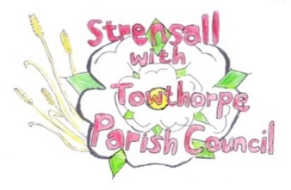**STRENSALL WITH TOWTHORPE PARISH COUNCIL**

The Village Hall, Northfields, Strensall, York YO325XW

e-mail: [strensalltowthorpePC@outlook.com](mailto:strensalltowthorpePC@outlook.com)

phone: 01904 491569

Chairman : Mr A H Fisher

**MINUTES OF AN PARISH COUNCIL MEETING HELD IN THE VILLAGE HALL ON TUESDAY 11th MARCH 2025 AT 7.00 PM**

**Councillors Present:** Andrew Bolton Chris Chambers Tony Fisher1 Lawrence Mattinson Susan Nunn John Shirbon

**In Attendance:** Fiona Hill – Parish Clerk

**Public Present:** 0

1 City of York Councillor

1. **a) To receive apologies for absence given in advance of the meeting:** Graham Green, Alan May, Daniel Pillai **b) To consider the approval of reasons given for absence:**  Resolved / Approved (Unanimous)

1. **To discuss the ordinary and casual vacancies:** NTR (Currently five)
2. **To receive any declarations of interest under the Parish Council Code of Conduct or**

**Members register of interests:** Cllr Chambers, St Marys Church Grant Request, Committee member

1. **a) To approve the minutes of the Parish Council meeting of 11th February 2025:**

Resolved / Approved (Unanimous)

**b) To endorse the approved Planning Committee minutes of 11th and 25th November 2024:**

Resolved / Endorsed (Unanimous)

1. **Public participation on any subject relating to the agenda:** None

**24/220 To receive matters raised by/with City of York Ward Councillors:** Cllr Fisher gave an update on the local plan and permissive rights of way

**24/221 To discuss and, if necessary, agree action on matters arising/ongoing issues:** a)North Yorkshire Police monthly reports – January 2025 report not received.

b) Community Memorial Garden – Governance, Signage, Christmas Tree, Future Planting Costs - NTR

c) Post RoSPA 2024 work – rocking horse repairs Wicksteed had quoted £1585.92 plus VAT for the parts required. Park Lane Services had quoted £40.00 x 2 people per hour and they could not say how long the work would take. The Parish Council deferred a decision until a cost for a replacement rocking horse is obtained.

**24/222 To discuss and, if necessary, agree action, on matters raised since last meetings:**

1. Possible sale of Oxford Allen The Parish Council agreed, in principle, to this equipment going to an agricultural equipment later in the year, but needs to know what the Horticultural Engineer, Brian Farrer, would charge for taking the equipment and if it doesn’t sell returning the equipment.
2. St Mary’s Church Grant Request Resolved / The Parish Council agreed a grant of £1000.00 (Unanimous)

**24/223 To discuss matters raised by/with Parish Clerk/Responsible Financial Officer (RFO):**

a) Bank reconciliation, income received, payments made to date:

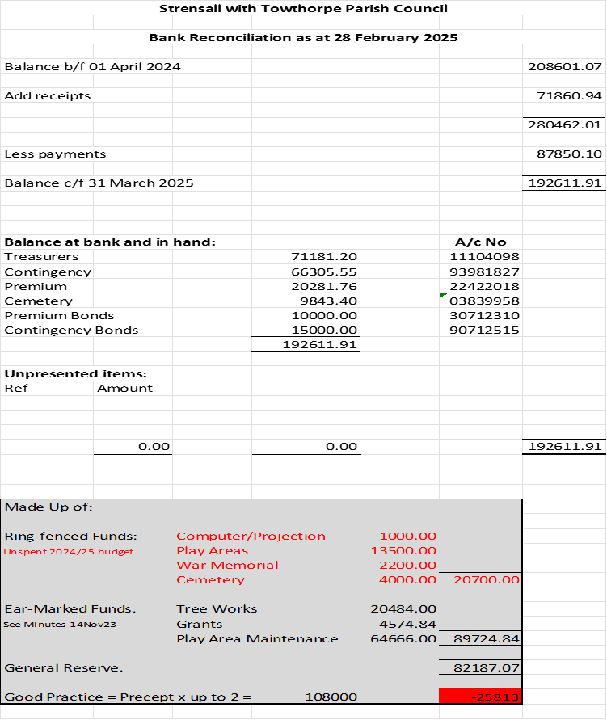

b) Payment Approval: None

c) Financial Management - Policy Review The final two policies are work in process – Risk Assessment and CCTV policy

d) Yorkshire Local Councils Association – are circulating guidance on year-end procedures.

e) Monthly Report from Parish Office: City of York Council has confirmed that the land adjacent to Knapton Close, as discussed at the last meeting (24/212c), is registered with the Land Registry with City of York Council. The Parish Council gave a vote of thanks to Cllr Lawrence and his wife for their assistance in translating this information to the resident.

**24/224 To confirm the date of the next meeting as Tuesday 08th April 2025 @ 7.00 p.m.:** Resolved / Approved (Unanimous)