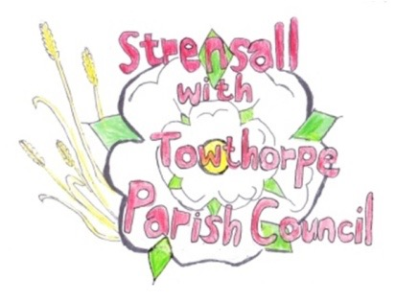 **STRENSALL WITH TOWTHORPE PARISH COUNCIL** The Village Hall, Northfields, Strensall, York YO325XW e-mail: [strensalltowthorpePC@outlook.com](mailto:strensalltowthorpePC@outlook.com) phone: 01904 491569

**MINUTES OF A PLANNING COMMITTEE MEETING HELD ON TUESDAY 11TH MARCH 2025 AT 6.30P.M.**

**Councillors Present:** Andrew Bolton Chris Chambers Tony Fisher Lawrence Mattinson

**In Attendance:** Fiona Hill - Parish Clerk

**Public Present:** 0

1. **a) To receive apologies for absence given in advance of the meeting:**  Graham Green

**b) To consider the approval of reasons given for absence:**  Resolved / Approved (Unanimous)

1. **To receive any declarations of interest under the Parish Council Code of Conduct or**

**Members register of interests:** None

1. **To approve the minutes of the Planning Committee meeting of 25th February 2025:**

Resolved / Approved (Unanimous)

1. **To discuss any ongoing issues and information received:** Cllr Fisher expressed concern at proposed government policy to reduce planning consultation with councils
2. **To consider and respond to consultations from City of York Council to the planning a applications as follows:**

a) 25/00151/FUL - Two storey extension to detached garage/home office @ 18 Moor Lane

Resolved / No Objection, but there is some concern that an extension on an extension means that the extension is not sub-servient to the main house, which contravenes the City of York Council Supplementary Planning Guidance. (Unanimous)

b) 25/00341/TCA - Remove co-dominant stem from 1no. Tree in a Conservation Area @ 21 Princess Road

Resolved / Objection, as the Parish Council is concerned that such a severe prune will affect the long-term health of the tree and would suggest the applicant consider crown reduction/thinning, which would be more sympathetic. (Unanimous)

Permission from the land-owner would be required before any work is done.

c) 25/00407/FUL - Variation of condition 2 of permitted application 24/01670/FUL to alter the approved plans and elevations @ Gorse Cottage Lords Moor Lane

Resolved/ No Objection (Unanimous)

1. **To note planning decisions received:**
2. 24/02241/FUL - Construction of 7no. Fishers bedroom lodges, separate shower block with combined office, formation of vehicle access and installation of 10no. car parking spaces @ Potteries Lake Pottery Lane - Withdrawn
3. 25/00289/FUL - Erection of 1no. dwelling to rear with associated vehicular access @ Gorse Cottage Lords Moor Lane - Withdrawn

**24/210 To confirm date of the next meeting on Tuesday 25th March 2025 @ 6.30 p.m.**

Resolved / Approved (Unanimous)