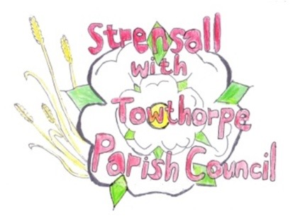 **STRENSALL WITH TOWTHORPE PARISH COUNCIL** The Village Hall, Northfields, Strensall, York YO325XW e-mail: [strensalltowthorpePC@outlook.com](mailto:strensalltowthorpePC@outlook.com) phone: 01904 491569

**MINUTES OF A PLANNING COMMITTEE MEETING HELD ON TUESDAY 28TH JANUARY 2025 AT 6.30P.M.**

**Councillors Present:** Andrew Bolton Chris Chambers Tony Fisher Graham Green

**In Attendance:** Fiona Hill - Parish Clerk

**Public Present:** 0

1. **a) To receive apologies for absence given in advance of the meeting:** None

**b) To consider the approval of reasons given for absence:** N/A

1. **To receive any declarations of interest under the Parish Council Code of Conduct or**

**Members register of interests:** None

1. **To approve the minutes of the Planning Committee meeting of 14th January 2025:**

Resolved / Approved (Unanimous)

1. **To discuss any ongoing issues and information received:** Cllrs noted updates on application for Gorse Cottage, Pottery Lane and 32 Westpit Lane
2. **To consider and respond to consultations from City of York Council to the planning a applications as follows:**
3. 24/02330/FUL - Change of use of paddock into a garden ancillary to new build house with associated boundary treatment @ Middleton House, 2 Redmayne Square

The Parish Council would request a further extension until the next meeting (11Feb25)

as two major issues arose:

* There is a challenge to the Neighbourhood Plan, about which the Parish Council wish to seek legal advice
* There is a query about land ownership and the Parish Council wish to consult with the Land Registry

1. 25/00006/FUL - Variation of condition 2 of permitted application 22/00446/FUL to alter elevations @ Middleton House, 2 Redmayne Square

Resolved / No Objections (Unanimous)

1. 25/00039/FUL - Single storey front and rear extensions and alterations to doors/windows @ 27 Princess Road

Resolved / No Objections (Unanimous)

1. 25/00054/FUL - Single storey side/rear extension @ Beckdale 118 The Village

Resolved / No Objections (Unanimous)

1. 25/00088/TCA - Various tree works including the felling of 1no. Plum and 1no. Hawthorn; crown reduce 1no. Maple and 2no. Silver Birch trees - tree works in a Conservation Area @ 119 The Village

Resolved / No Objections, subject to guidance from the CYC Tree Office and the work done by a qualified tree surgeon (Unanimous)

1. 25/00089/TCA - Removal of 1no. branch from a tree in a Conservation Area @ 121 The Village Resolved / No Objections (Unanimous)

1. **To note planning decisions received:** 24/01819/PAAA - Enlargement of dwellinghouse by construction of 1no. additional storey with new roof height no greater than 3.5 metres above the highest part of the existing roof

under Town and Country Planning (General Permitted Development) (England) Order 2015 (as amended) - Schedule 2, Part 1, Class AA @ 36 Moor Lane - Approved

**23/189 To confirm date of the next meeting on Tuesday 11th February 2025 @ 6.30 p.m.** Resolved / Approved (Unanimous)