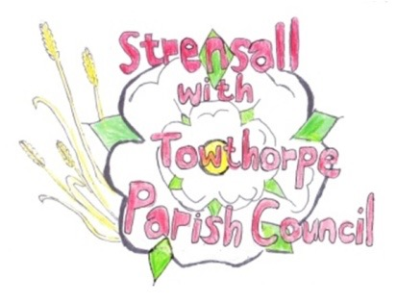 **STRENSALL WITH TOWTHORPE PARISH COUNCIL** The Village Hall, Northfields, Strensall, York YO325XW e-mail: [strensalltowthorpePC@outlook.com](mailto:strensalltowthorpePC@outlook.com) phone: 01904 491569

**MINUTES OF A PLANNING COMMITTEE MEETING HELD ON TUESDAY 25TH FEBRUARY 2025 AT 6.30P.M.**

**Councillors Present:** Andrew Bolton Chris Chambers Tony Fisher Graham Green

**In Attendance:** Fiona Hill - Parish Clerk

**Public Present:** 0

1. **a) To receive apologies for absence given in advance of the meeting:** Lawrence Mattinson

**b) To consider the approval of reasons given for absence:**  Resolved / Approved (Unanimous)

1. **To receive any declarations of interest under the Parish Council Code of Conduct or**

**Members register of interests:** None

1. **To approve the minutes of the Planning Committee meeting of 11th February 2025:**

Resolved / Approved (Unanimous)

1. **To discuss any ongoing issues and information received:** The Parish Council would not submit further comment to the appeal regarding 32 West Pit Lane.
2. **To consider and respond to consultations from City of York Council to the planning a applications as follows:** 25/00289/FUL – Erection of 1 no. dwelling to rear with associated vehicular access @ Gorse Cottage, Lords Moor Lane Resolved / No Objections (Unanimous) - The new driveway must be constructed in such a way as to not adversely effect the flows

of various water courses along the Eastern side of Lords Moor Lane, as there is a confluence of two water courses in the land in front of Gorse Cottage including a water course which crosses Lords Moor Lane itself.

- The applicant needs to seek permission from landowner to (1) cross land to gain access to highway and (2) fell any trees.

1. **To note planning decisions received:** a) 24/01670/FUL - Erection of 1no. dwelling (use class C3) to rear with associated access/landscaping and replacement double detached garage to main dwelling @

Gorse Cottage, Lords Moor Lane - Approved

1. **To confirm date of the next meeting on Tuesday 11th March 2025 @ 6.30 p.m.**

Resolved / Approved (Unanimous)