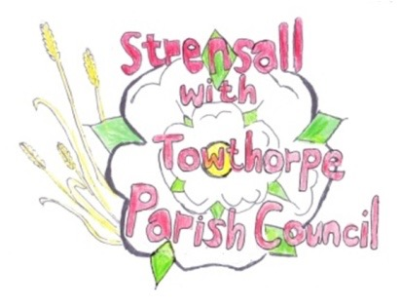 **STRENSALL WITH TOWTHORPE PARISH COUNCIL** The Village Hall, Northfields, Strensall, York YO325XW e-mail: [strensalltowthorpePC@outlook.com](mailto:strensalltowthorpePC@outlook.com) phone: 01904 491569

**MINUTES OF A PLANNING COMMITTEE MEETING HELD ON TUESDAY 08TH APRIL 2025 AT 6.30P.M.**

**Councillors Present:** Andrew Bolton Chris Chambers Tony Fisher Graham Green Lawrence Mattinson

**In Attendance:** Fiona Hill - Parish Clerk

**Public Present:** 1

1. **a) To receive apologies for absence given in advance of the meeting:** None

**b) To consider the approval of reasons given for absence:** N/A

1. **To receive any declarations of interest under the Parish Council Code of Conduct or**

**Members register of interests:** None

1. **To approve the minutes of the Planning Committee meeting of 25th March 2025:**

Resolved / Approved (Unanimous)

1. **To discuss any ongoing issues and information received:** Cllr Fisher gave an update on the development SD9 at North Haxby, which had currently

been withdrawn to address issues raised

1. **To consider and respond to consultations from City of York Council to the planning a applications as follows:**

a) 25/00577/TCA – Fell 1no. Pear tree in a Consevative Area @ 101 The Village

Resolved / Objection, There is no clear evidence that the tree is diseased, so there is no reason to fell the tree. A full and clear specification, produced by an independent tree surgeon should be provided (Unanimous)

1. **To note planning decisions received:**

a)24/02348/FUL – Single storey side and rear extension @ 14 Fold Walk - Approved

1. **To confirm date of the next meeting on Tuesday 22nd April 2025 @ 6.30 p.m.**

Resolved / Approved (Unanimous)