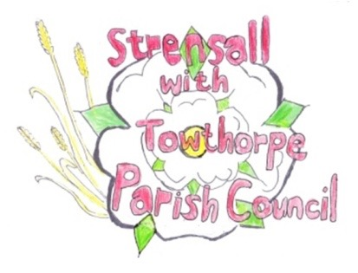
STRENSALL WITH TOWTHORPE PARISH COUNCIL The Village Hall, Northfields, Strensall, York YO325XW e-mail: strensalltowthorpePC@outlook.com phone: 01904 491569

MINUTES OF A PLANNING COMMITTEE MEETING HELD ON TUESDAY 08TH APRIL 2025 AT 6.30P.M.
Councillors Present: Andrew Bolton Chris Chambers Tony Fisher Graham Green Lawrence Mattinson
In Attendance: Fiona Hill - Parish Clerk
Public Present: 1
- a) To receive apologies for absence given in advance of the meeting: None
b) To consider the approval of reasons given for absence: N/A

- To receive any declarations of interest under the Parish Council Code of Conduct or
Members register of interests: None

- To approve the minutes of the Planning Committee meeting of 25th March 2025:
Resolved / Approved (Unanimous)

- To discuss any ongoing issues and information received: Cllr Fisher gave an update on the development SD9 at North Haxby, which had currently
been withdrawn to address issues raised

- To consider and respond to consultations from City of York Council to the planning a applications as follows:

a) 25/00577/TCA – Fell 1no. Pear tree in a Consevative Area @ 101 The Village
Resolved / Objection, There is no clear evidence that the tree is diseased, so there is no reason to fell the tree. A full and clear specification, produced by an independent tree surgeon should be provided (Unanimous)
- To note planning decisions received:
a) 24/02348/FUL – Single storey side and rear extension @ 14 Fold Walk - Approved

- To confirm date of the next meeting on Tuesday 22nd April 2025 @ 6.30 p.m.
Resolved / Approved (Unanimous)

