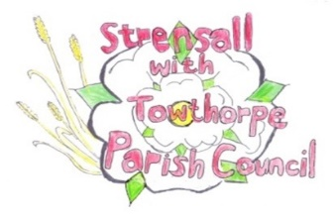
STRENSALL WITH TOWTHORPE PARISH COUNCIL
The Village Hall, Northfields, Strensall, York YO325XW
e-mail: strensalltowthorpePC@outlook.com
phone: 01904 491569
Chairman : Mr A H Fisher

MINUTES OF AN PARISH COUNCIL MEETING HELD IN THE VILLAGE HALL ON TUESDAY 09^{h} SEPTEMBER 2025 AT 7.00 PM
Councillors Present: Andrew Bolton Thomas Carmicheal Chris Chambers David Dale Tony Fisher¹ Graham Green Lawrence Mattinson Alan May Susan Nunn Daniel Pillai John Shirbon
In Attendance: Fiona Hill – Parish Clerk

Public Present: 0
¹ City of York Councillor
- a) To receive apologies for absence given in advance of the meeting: Parish Councillors Anthony Drake² and Simon Hide¹ b) To consider the approval of reasons given for absence: ¹ Resolved / Approved (Unanimous)
² No reason given, so approval not possible

- a) To discuss the vacancy: Nothing to report b) To invite recently co-opted members to join committees: Nothing to report

- To receive any declarations of interest under the Parish Council Code of Conduct or
Members register of interests: None

- a) To approve the minutes of the Parish Council meeting of 12th August 2025:
Resolved / Approved (Unanimous)
b) To endorse the approved Planning Committee minutes of 12th August 2025:
Resolved / Endorsed (Unanimous)

- Public participation on any subject relating to the agenda: None
24/280 To receive matters raised by/with City of York Ward Councillors: * Northern Gas works at Towthorpe crossroads * Boundary Commission Review * CYC proposed amendments to the Scheme of Delegation for Planning Committees * a flood report, for the recent inspections along Lords Moor Lane and The Village was expected soon
Cllr Fisher had been unable to establish who the landowner was where the damaged tree is along York Road. The Parish Council would obtain a quote for felling the tree. This, along with removal of the unsightly arising on MOD land adjacent, would be discussed at the next meeting.
24/281 To discuss and, if necessary, agree action on matters arising/ongoing issues: a) North Yorkshire Police monthly reports – August 2025 report circulated/noted. b) Community Memorial Garden – Governance, Planting, Etc Cllr Fisher continues to chase up CYC legal dept regarding the lease agreement. The Parish Council would contact companies to try and obtain a donation of a Christmas Tree.
24/282 To discuss and, if necessary, agree action, on matters raised since last meetings:
- Winter flower planting Resolved / The Parish Council would only plant out the six village signs, not the tubs. Cllr Nunn was authorized to spend up to £30.00 on winter flowering pansies for the village signs and £40.00 on daffodil bulbs, which the scouts would plant (Unanimous)
- Tree works – current/proposed
Lewis Trees had conducted a climbed inspection of the Oaks in Northfields Play Park and are now doing the recommended works. Lewis Trees will inspect the trees in Northfields allotments, adjacent to the tree that recently failed, then issue a report on the health of the trees. On the open space adjacent to West Pitt Lane, two English Oaks, were outgrowing the straps/cages, so quotes would be obtained for their removal.

The street light near the war memorial was obstructed by overgrowth, so a quote would be obtained for cutting back.

Cllr Bolton and the Parish Clerk had taken away the collapsed part of the fence adjacent to the village hall car park. The existing part of the fence appeared OK. The Parish Council would not replace the fence at this stage.

24/283 To discuss matters raised by/with Parish Clerk/Responsible Financial Officer (RFO): a) Bank reconciliation, income received, payments made to date: The Parish Clerk reported – “At the July 2025 meeting a comparison to budget report for the period 01 April 2025 – 30 June 2025 was presented. Below are the summaries for 01 July 2025 – 31 August 2025. At the October 2025 meeting a comparison to budget report for the period 01 July 2025 – 30 September 2025 will be presented”
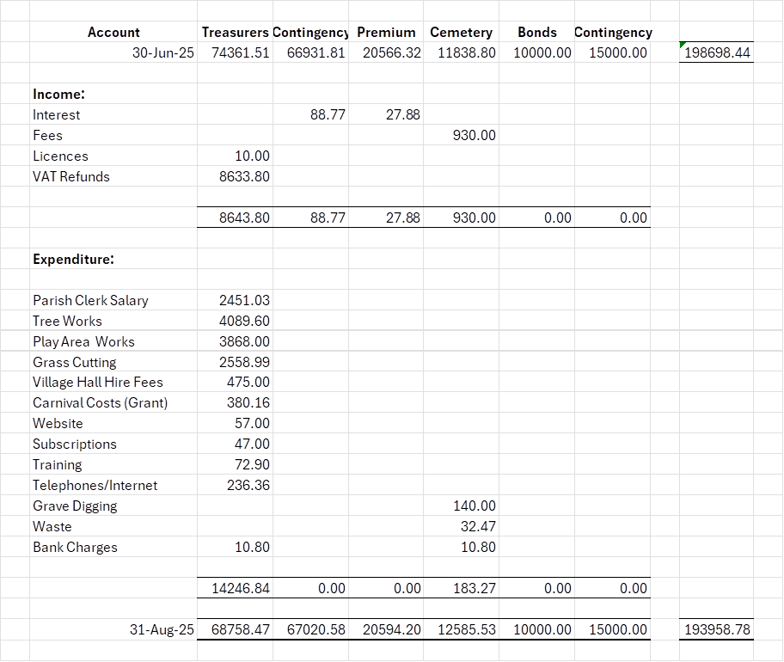
b) Payment Approval: None c) Financial Management - Scribe Management System – Accounting, Cemetery, (Allotment), (Bookings) Resolved / The Parish Council agreed to move from excel spreadsheets to cloud-based applications based on the quote received. (Unanimous) d) Yorkshire Local Councils Association New assertion 10 in the Annual Governance and Accountability Return for year ended 31 March 2026 The Parish Council noted the content of the guidance, would keep a watching brief, but take no action at this stage. e) Monthly Report from Parish Office – Nothing to report
24/284 To confirm the date of the next meeting as Tuesday 14th October 2025 at 7.00 p.m. Resolved / Approved (Unanimous)

