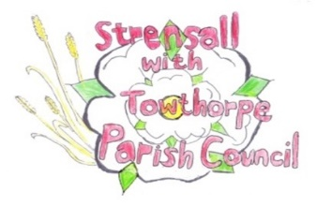
STRENSALL WITH TOWTHORPE PARISH COUNCIL
The Village Hall, Northfields, Strensall, York YO325XW
e-mail: strensalltowthorpePC@outlook.com
phone: 01904 491569
Chairman : Mr A H Fisher

MINUTES OF AN PARISH COUNCIL MEETING HELD IN THE VILLAGE HALL ON TUESDAY 11th FEBRUARY 2025 AT 7.00 PM
Councillors Present: Andrew Bolton Chris Chambers Tony Fisher¹ Graham Green Lawrence Mattinson Alan May Susan Nunn Daniel Pillai John Shirbon
In Attendance: Fiona Hill – Parish Clerk

Public Present: 0
¹ City of York Councillor
- a) To receive apologies for absence given in advance of the meeting: None b) To consider the approval of reasons given for absence: N/A
- To discuss the ordinary and casual vacancies: NTR (Currently five)

- To receive any declarations of interest under the Parish Council Code of Conduct or
Members register of interests: Cllr Chambers, 8a, Committee member
Cllr Lawrence. 8c, Friend of resident

- a) To approve the minutes of the Parish Council meeting of 14th January 2025:
Resolved / Approved (Unanimous)
b) To endorse the approved Planning Committee minutes of 14th and 28th November 2024:
Resolved / Endorsed (Unanimous)

- Public participation on any subject relating to the agenda: None
24/210 To receive matters raised by/with City of York Ward Councillors: Cllr Fisher gave an update budgeting and the local plan.

24/211 To discuss and, if necessary, agree action on matters arising/ongoing issues: a) North Yorkshire Police monthly reports – January 2025 report not received.
b) Community Memorial Garden – Governance, Signage, Christmas Tree, Future Planting Costs The Parish Council agreed that: - around the bench, trees could be moved/replanted and additional tree planted - the dog litter bin could be moved to the other side of the footpath - flowers could be planted around the Yorkshire Water drain, as these could easily be removed/replaced, if access were needed. - there was room for six memorial trees and Cllr Nunn would draw a plan to identify locations. - Cllr Fisher would speak to the CYC Legal Dept about the lease documentation
c) Play Areas – Resistance Penetration Wood Drill Tests Prior to the meeting the Parish Clerk reported as follows – “Playsafety Ltd attended on 17th January 2025 to conduct the Resistant Penetration Drill Tests on wooden play equipment as follows:
Kirklands
- Swing – Toddler – 1 Bay 2 Seat (1850 mm)
- Swing – Junior – 1 Bay 2 Seat
- Agility Trail
- Multiplay – Climber – Low
- Agility Trail – New
- Multiplay – Slide Climber
Northfields
- Swing – Junior – 1 Bay 2 Seat (Near Rocking Horse)
- Swing – Junior – 1 Bay 2 Seat (Near Climber)
- Swing – Nest
- Climber – Frame & Net
On the day, Playsafety emailed to report two High Risk Findings:
Kirklands - Swing - Junior - 1 Bay 2 Seat
Northfields - Swing – Nest
Then later that day, they sent the full reports, so I contacted Park Lane Services, who were on site conducting the post ROSPA works.
Park Lane Services removed and have stored the seats of the equipment marked High or High Medium Risk –

Northfields:
- Swing – Nest
- Swing – Junior – 1 Bay 2 Seat (Near Climber)
- Swing – Junior – 1 Bay 2 Seat (Adjacent Rocking Horse)

Kirklands:
- Swing – Junior – 1 Bay 2 Seat
- Swing – Toddler – 1 Bay 2 Seat

Park Lane will quote for each piece of equipment as follows:
- To replace the decayed timbers (quote not provided)
- To supply and erect replacement in wood
- To supply and erect replacement in metal
Park Lane had quoted as follows:
To supply/erect - Junior Swings – Metal – Each/Plus VAT - £5450.00 – Three Required To supply/erect - Junior Swings – Wood – Each/Plus VAT - £5760.00 – Three Required
To supply/erect - Cradle Swings – Metal – Each/Plus VAT - £4770.00 – One Required To supply/erect - Cradle Swings – Wood – Each/Plus VAT - £5698.00 – One Required
To supply/erect - Nest Swings – Metal – Each/Plus VAT - £5570.00 – One Required To supply/erect - Nest Swings – Wood – Each/Plus VAT - £6010.00 – One Required
The seats and chains removed from the current swings would be re-fixed
Resolved / The Parish Council accepted the quotations for Metal swings (Unanimous)
24/212 To discuss and, if necessary, agree action, on matters raised since last meetings:
- Strensall Community Events – Grant Request The Committee had requested £1500.00 for road closure and £316.80 for first aid provision. Resolved – Approved (Unanimous)

- Tree works – Urgent issues due to storm damage A tree had blown down adjacent to footpath outside the property Little Hague, taking down their telephone cables. The Parish Council arranged for these to be removed, so BT could proceed with the reconnection.

- Land owned/leased by Parish Council – unauthorized use

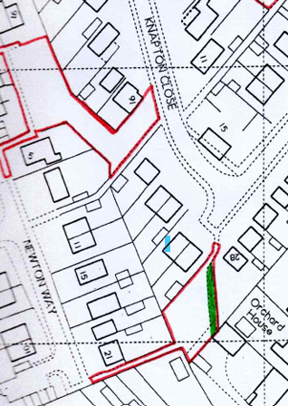
Resolved / The Parish Council would consult with the Land Registry/City of York Council to establish ownership of the community land adjacent to the 28 Knapton Close. The land and the property were owned by the MOD, the land being used as a car park. (Unanimous)
The Parish Council would allow, on a permissive basis, the parishioner to continue growing produce on the land, but it should not be fenced off and it does not give a right to ownership. The Parish Council can withdraw notice, with reasonable notice, without giving a reason.
24/213 To discuss matters raised by/with Parish Clerk/Responsible Financial Officer (RFO):
a) Bank reconciliation, income received, payments made to date:
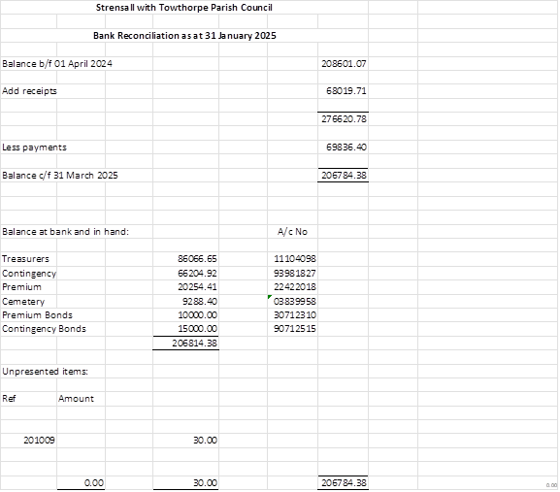
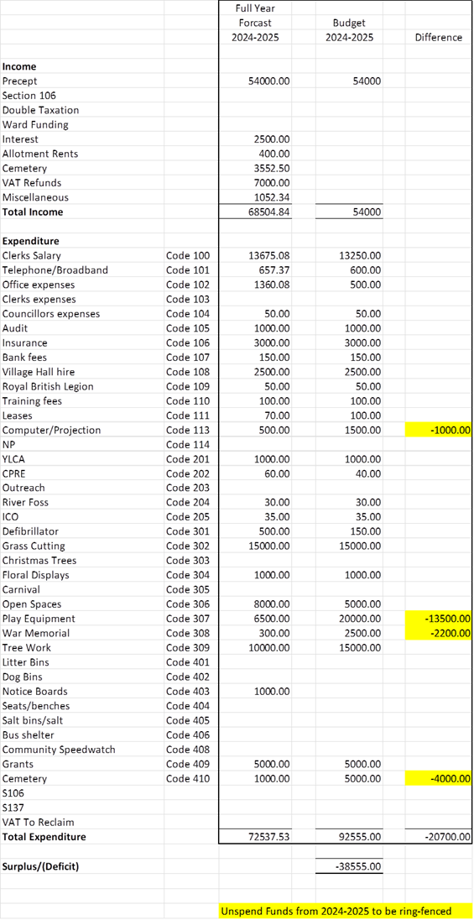
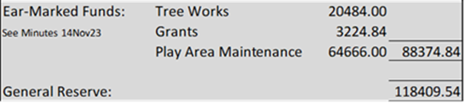
b) Payment Approval: None
c) Financial Management - Policy Review
At the 2024 Annual Parish Council Meeting the Parish Clerk reported that she had conducted a review of the policies and the YLCA Checklist was updated with the work done throughout the year. However, seven policies still require work - Risk Assessments, Websites Management Policy, Website Accessibility Statement, CCTV, Social Media, Business Continuity Plan and Health & Safety.
The Parish Clerk has re-started this work as follows:
Health and Safety - It is only mandatory to have a Health and Safety Policy in place if there are five or more employees of the council. However, the YLCA do offer the HSE template for anyone to use and a draft populated using the example wording offered on the HSE website was circulated
Business Continuity Plan - YLCA template draft circulated to Cllrs
Social Media Policy - YLCA template draft circulated to Cllrs
Website Management Policy:
The Parish Clerk is responsible for managing the information on the website.
A Parish Council website has two main functions:
- To communicate all of the legally required information as indicated in the Transparency Code for smaller authorities 2014. In simple terms, this includes Agendas, Minutes and designated financial information.

- Secondly, if the Parish Council wishes, to communicate other information relating to the Parish which is not legally required – but is helpful.
Website Accessibility statement
The Parish Council is constantly working to make our website as accessible and usable as possible.
Our website has been developed to best practice coding conventions.
A consistent heading structure has been used so that page information is compatible with access technology.
A number of browsers, including Internet Explorer and Google Chrome have been tested for compatibility.
If you would like a publication in an alternative format please contact the Parish Council
The Parish Council is always happy to receive feedback and you can contact the Parish Council on strensalltowthorpepc@outlook.com Resolved / The five policies listed above were adopted (Unanimous)
d) Yorkshire Local Councils Association - Nothing to report
e) Monthly Report from Parish Office:
The Village Hall have a booking for celebrating the Sri Lankan New Year on 04 May 2025 and they have asked permission to have a gate opened to enable access directly from the Village Hall. Resolved / The Parish Council would ensure the gate was unlocked before the event and re-locked after the event. The Northfields Park rules would be shared with the family (Unanimous)
At 69 The Village, consent had been awarded, on appeal, to fell the tree. The applicant had contacted the Parish Council to advise that they would provide a replacement tree and wanted to know the preferred location. The Parish Council would give this some thought and get back to the applicant ASAP.
A local bus company had contacted the Parish Council to claim costs for tree branches allegedly breaking windscreen on two occasions. The information provided to City of York Council and the Parish Council gave differing locations, so it is probable that the tree was not on Parish Council land. The Parish Council would write accordingly.
24/214 To confirm the date of the next meeting as Tuesday 11th March 2025 @ 7.00 p.m.: Resolved / Approved (Unanimous)

