
STRENSALL WITH TOWTHORPE PARISH COUNCIL
The Village Hall, Northfields, Strensall, York YO325XW
e-mail: strensalltowthorpePC@outlook.com
phone: 01904 491569
Chairman : Mr A H Fisher

MINUTES OF AN PARISH COUNCIL MEETING HELD IN THE VILLAGE HALL ON TUESDAY 14th OCTOBER 2025 AT 7.15 PM
Councillors Present: Andrew Bolton Thomas Carmicheal Chris Chambers David Dale Tony Fisher¹ Graham Green Simon Hide Lawrence Mattinson Alan May Daniel Pillai John Shirbon
In Attendance: Fiona Hill – Parish Clerk

Public Present: 1 – Sarah Glynn
¹ City of York Councillor
- a) To receive apologies for absence given in advance of the meeting: None b) To consider the approval of reasons given for absence: N/A

- To discuss the vacancy: Sarah Glynn was co-opted into the Parish Council

- To receive any declarations of interest under the Parish Council Code of Conduct or
Members register of interests: None

- a) To approve the minutes of the Parish Council meeting of 09th September 2025:
Resolved / Approved (Unanimous)
b) To endorse the approved Planning Committee minutes of 09th and 23rd September 2025:
Resolved / Endorsed (Unanimous)

- Public participation on any subject relating to the agenda: None
24/290 To receive matters raised by/with City of York Ward Councillors: Cllr Fisher gave updates as follows - * Lendal Bridge closure * Haxby Station * Flags on street lights * Redmayne Square landscaping

24/291 To discuss and, if necessary, agree action on matters arising/ongoing issues: a) North Yorkshire Police monthly reports – September 2025 report not received b) Scribe software updates The system is now live and the data is in the process of been transferred. The cemetery commenced 01 October 2025 and the accounts will commence 01 April 2026. The scanning/uploading of paper records is ongoing. c) Community Memorial Garden – Christmas tree York Christmas Trees had emailed as follows – “Thank you for your email what a lovely idea to create a community garden in Strensall. As you can imagine, we have an awful lot of request for free trees every year (over 54 requests last year) in the past we have gifted Trees via the good causes on Yorkmix radio and their annual hero awards. We also gift to York hospital, St Leonard’s hospice ,mental health charities and a women’s refuge to name but a few…. We are discussing running our own charity tree lucky dip …in which case I will add you to the list and you will received an email regarding this in the not too distant future”. d) Bus shelter in front of Strensall Fisheries – hedge/litter bin Cllr Fisher and the Parish Clerk had met Mr Oldroyd on site and reported that as the hedge was in a conservation area and does not hugely affect visibility, it should not be cut back. The Parish Council unanimously agreed this course of action. The location for the litter bin was still been discussed. e) Obstructed streetlight near war memorial The Parish Council had received two quotations for this work. Resolved / The Parish Council would accept a quote of £140.00 plus VAT from Lewis Tree Surgery & Landscaping. In addition, they would be asked to cut back low branches above the seat next to the war memorial. f) Fallen tree and arisings along York Road The Parish Council had received two quotations for this work. Resolved / The Parish Council would accept a quote of £575.00 plus VAT from Lewis Tree Surgery & Landscaping. g) Inspection of trees in Northfields allotments The Parish Council had conducted a inspection of twenty-one trees and urgent work on trees T10 and T13 would be done on 27th October. High priority work on trees T1, T2, T9, T12 and T14 will be discussed at the next meeting.
The Parish Council read a statement detailing the events which lead to this report been commissioned: On Sunday 03rd August 2025, two branches from an Oak tree in the allotments adjacent to 10 Netherwoods, fell on the garden at the side of the house.
The fence, shed and green house were damaged.
Cllr Chambers and his wife kindly helped their neighbours clear the site.
I arranged for two contractors to quote for supplying and erecting replacement shed and greenhouse, along with replacing the damaged fence.
Quotes were obtained: Greenhouse £9541.00 including VAT Shed/Fence £4507.20 including VAT and forwarded to the Parish Councils insurance company
The Parish Councils insurance company has advised that I should have: 1. Contacted them immediately 2. Advised Mr Thomas to contact his insurance company And no further action should have been taken until given the official go ahead.
By assisting Mr Thomas, I may have “implied” acceptance of liability, which could prejudice any claim.
I am now working with the Parish Council insurance company, but the worse case scenario could be that the repairs would have to be paid for by the Parish Council.
h) Annual Governance and Accountability Return (AGAR) – Digital Presence Parish Online, who operate as a not-for-profit social enterprise are offering free gov.uk emails for Parish Clerks, so this Parish Council has applied for one. There are packages available for adding councillor emails
i) Planning Inspectorate ROW / 3362930: Westpit Strensall, YO32 5RY Cllr Fisher gave a report on this to the Parish Council.
24/292 To discuss and, if necessary, agree action, on matters raised since last meetings:
- Play Areas – ROSPA Inspections (Sep25) Parish Council had received copies of the reports via email from the Parish Clerk.
The Parish Council would obtain quotes for three issues as follows:
- Kirklands – Swing seat repair
- Northfields – Swing seat bolt replacement
- Northfields – Rotator surface repair
Going forward, a Parish Councillor would be nominated a the Parish Council meeting, who would inspect the play area and report back at the next meeting. Any urgent issues would be reported to the Parish Clerk immediately. Parish Councillor Chambers was nominated and would report at the next meeting.
- Cemetery – Headstones – Visual Inspections, Manual Push/Pull Hand Tests The Parish Council had visually inspected and photographed all headstones/memorials in the cemetery. The photographs would be uploaded to the new computer system. The Manual Push/Pull Hand Test was conducted on all grave headstone and two were found to be loose on their bases, so the Parish Clerk had written to the families.

24/293 To discuss matters raised by/with Parish Clerk/Responsible Financial Officer (RFO): a) Bank reconciliation, Receipts and Payments to date, including budget comparison 01Apr25 – 30Sep25:
The Parish Clerk reported – “Below is the bank reconciliation. The balances are healthy, with reasonable ring-fenced/ear-marked reserves, which leaves a General Reserve within acceptable boundaries”.
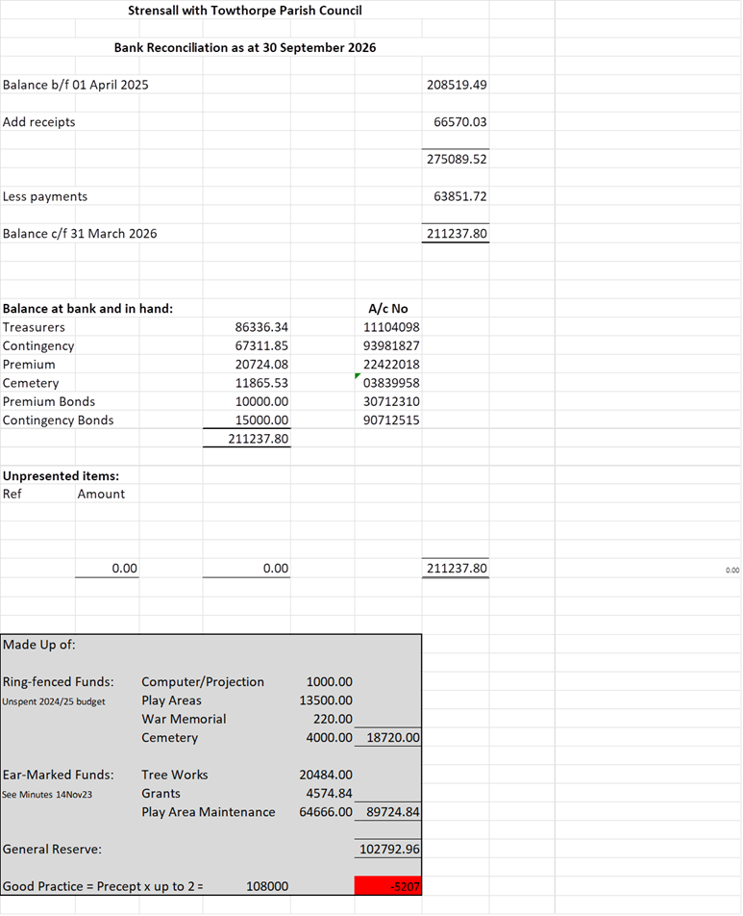 b)
Payment Approval: None
c) Financial Management – Budget/Precept 2026/2027
The Parish Clerk reported – “Below is the actual to date and budget costs, along with the estimated full year costs and full year budget differences. In conclusion, to date, I can report the expenditure in closely in line with budget and where there is overspend, there are reserves to cover this”.
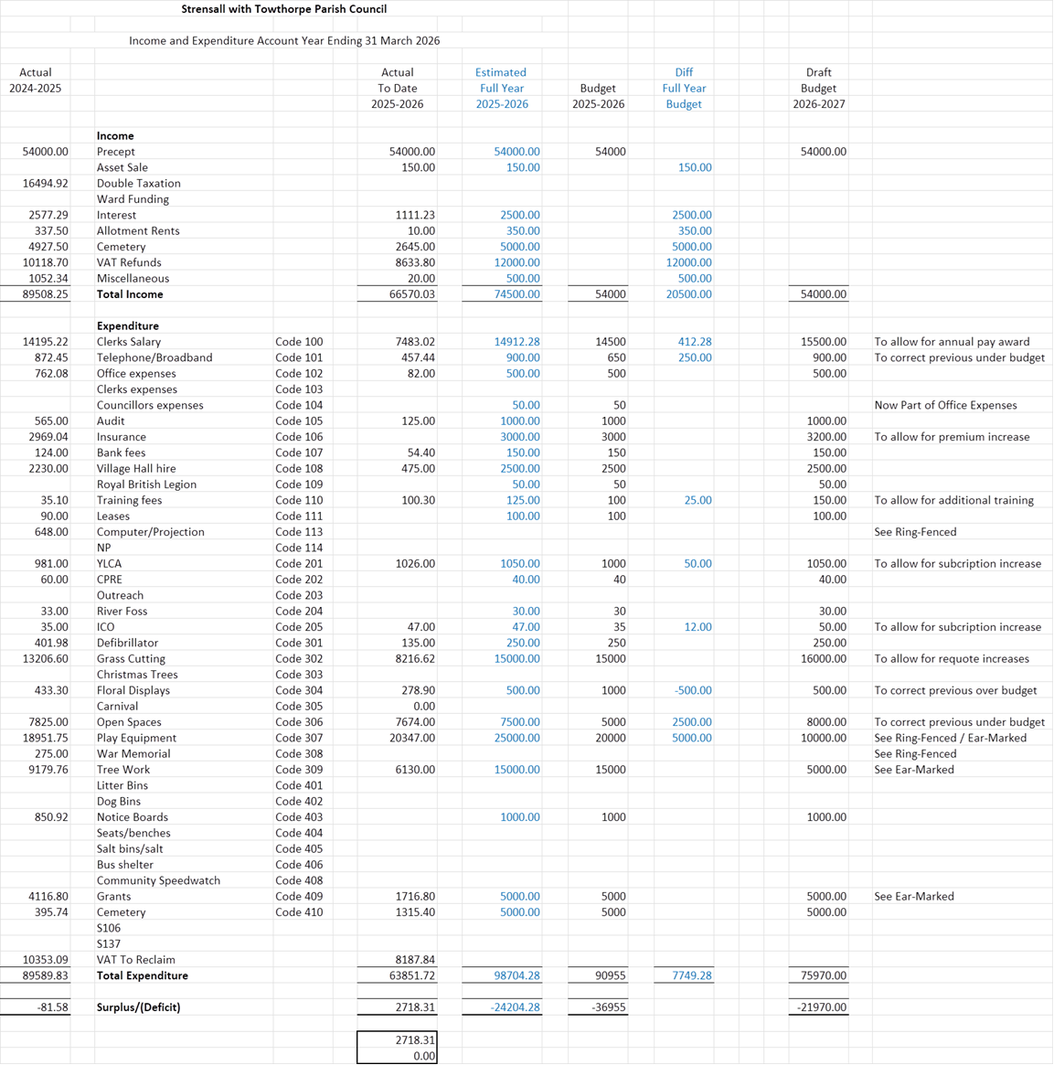
The Parish Clerk reported – Finally, in the column further most to the right, I have issued the first draft of the budget for the year 2026-2027. Keeping the precept at £54000, I have balanced the use of reserves, against a thoughtful budget based on expected expenditure.
The Parish Council would discuss this further at the next meeting.
d) Yorkshire Local Councils Association - Nothing to report
e) Monthly Report from Parish Office: The Parish Clerk was currently inspecting all assets listed on the register and had completed checking the noticeboards, plants and seats.
A handyman (Jon Brooks) had been asked to complete a list of tasks as follows: - Apply wood treatment to three wooden noticeboards at Tudor Way, West End, Towthorpe and repair the noticeboard on the library wall - Weed and strim around all thirteen planters - Remove the trip hazzard left after the fence collapsed adjacent to the village hall car park - Clear the overgrown vegetation from the area between the fence and hedge adjacent to the railway.
A list of the seats needing wood treatment would be forwarded to the handyman when list completed.
24/294 a) To confirm the date of the next meeting as Tuesday 11th November 2025 at 7.00 p.m. Resolved / Approved (Unanimous) b) To confirm locum arrangements during Parish Clerks holiday The office will be closed w/c Monday 10 November 2025, w/c Monday 17 November 2025 and Monday 24 November 2025 only. The locum clerk will have access to the telephone land line via the mobile phone and cemetery records via the new computer system (Scribe). The locum clerk will be in attendance at meetings on Tuesday 11 November 2025 and Tuesday 25 November 2025

