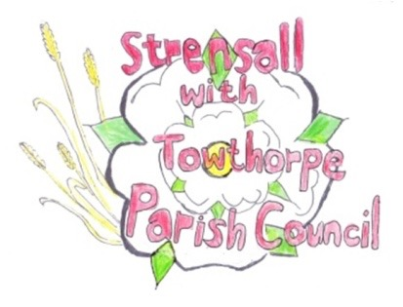
STRENSALL WITH TOWTHORPE PARISH COUNCIL The Village Hall, Northfields, Strensall, York YO325XW Email: strensalltowthorpePC@outlook.com Telephone: 01904 491569

MINUTES OF A PLANNING COMMITTEE MEETING HELD ON TUESDAY 09th SEPTEMBER 2025 AT 6.30P.M.

Councillors Present: Andrew Bolton Thomas Carmicheal Chris Chambers Tony Fisher Graham Green Lawrence Mattinson
In Attendance: Fiona Hill - Parish Clerk
Public Present: 0

- a) To receive apologies for absence given in advance of the meeting: None
b) To consider the approval of reasons given for absence: N/A

- To receive any declarations of interest under the Parish Council Code of Conduct or
Members register of interests: None

- To approve the minutes of the Planning Committee meeting of 12th August 2025:
Resolved / Approved (Unanimous) (Meeting on 26th August 2025 was cancelled)

- To discuss any ongoing issues and information received:
The Parish Council noted the content of an email from City of York Council regarding amendments to the Scheme of Delegation for Planning Committees
24/270 To consider and respond to consultations from City of York Council to the planning a applications as follows:

- 25/01616/TPO - Crown lift 1no. Oak to 5.2m above ground level to over highway and up to 1m lateral reduction of crown over driveway - tree protected by Tree Preservation Order 189A @ The Oak 46 Moor Lane
Resolved / Neutral, No Objection subject to guidance from City of York Council Tree Officer and work conducted by a qualified tree surgeon (Unanimous)
- 25/01640/FUL - Single storey rear extension @ 15 Littlethorpe Close
Resolved / Neutral, No Objection (Unanimous)
- 25/01656/TCA – Fell 1no. Christmas tree (rear garden) - tree in a conservation area @ The Coach House, Southfields Road
Resolved / Neutral, No Objection, but a modest deciduous tree should be planted at a suitable site in the parish. (Unanimous)
- 25/01713/TCA - Fell 1no. Silver Birch (rear gdn) - tree in a conservation area @ The Stables, 70 The Village
Resolved / Objection, as the tree should be pruned on a regular basis rather than be felled (Unanimous)

24/271 To note planning decisions received: a) 25/01046/FUL - Two storey rear and single storey side extensions @ 6 Adlington Close – Approved b) 25/01281/FUL - Single storey rear extension @ 4 Chapman Close – Approved c) 25/01384/FUL - Partial conversion of garage into habitable space with associated external alterations @ Church Farm 15 Church Lane - Approved
24/272 To confirm date of the next meeting on Tuesday 23rd September 2025 @ 6.30 p.m. Resolved / Approved (Unanimous)

