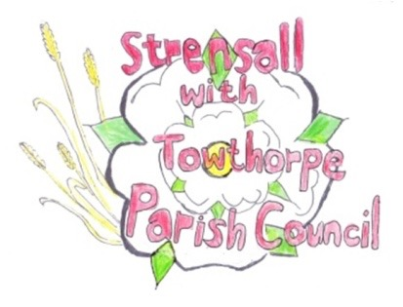
STRENSALL WITH TOWTHORPE PARISH COUNCIL The Village Hall, Northfields, Strensall, York YO325XW Email: strensalltowthorpePC@outlook.com Telephone: 01904 491569

MINUTES OF A PLANNING COMMITTEE MEETING HELD ON TUESDAY 12th AUGUST 2025 AT 6.30P.M.

Councillors Present: Andrew Bolton Thomas Carmicheal Chris Chambers Tony Fisher Graham Green
In Attendance: Fiona Hill - Parish Clerk
Public Present: 0

- a) To receive apologies for absence given in advance of the meeting:
Lawrence Mattinson
b) To consider the approval of reasons given for absence: Resolved / Approved (Unanimous)

- To receive any declarations of interest under the Parish Council Code of Conduct or
Members register of interests: None

- To approve the minutes of the Planning Committee meeting of 08th July 2025:
Resolved / Approved (Unanimous) (Meeting on 22th July 2025 was cancelled)

- To discuss any ongoing issues and information received: None
24/264 To consider and respond to consultations from City of York Council to the planning a applications as follows: a) 25/01424/FUL - Single storey side and rear extension @ 68 Barley Rise
Resolved / Neutral, No objections, but the remaining driveway should be sufficient to accommodate two cars.
- 25/01458/TPO - Reduce the branch work extending into garden by approximately 2.4 meters and removal of one damaged limb of 1no. Oak protected by Tree Preservation Order CYC 285 @ 16 Heath Ride
Resolved / Neutral, No comment, as there are no documents on the planning portal, so the work should be done under the guidance of the City of York Council Tree Officer.
- 25/01488/FUL - Pitched roof to existing garage, conversion of detached garage to habitable space, timber fence to boundary perimeter and new access driveway gates @ 4 Newton Way
Resolved / Neutral, No objections, but the extension should be subservient to the main property and not occupied as a separate dwelling.

- 25/01536/TCA - Remove large branch overhanging 61 The Village from 1no. Ash (located at 67 The Village) - tree in a conservation area @ Aleppo, 67 The Village
Resolved / Neutral, No comment, but the work should be done under the guidance of the City of York Council Tree Officer and not adversely affect the life of the tree.

24/265 To note planning decisions received:
a) 25/00632/FUL - Variation of conditions 2 of permitted application 24/00645/FUL to alter the proposed plans and elevations and removal of condition 3 @ Ivanhoe, 8 West End - Approved
b) 25/00878/FUL - Two storey side extension, render to front elevation, new portico and alterations to windows to front after removal of porches to front and side @ 33 Southfields Road - Approved
c) 25/00910/FUL - Replacement of existing open steel mesh gates to the south porch of church with new high quality oak and glass doors @ St Marys Church, Church Lane - Approved
d) 25/00931/FUL - Single storey side and rear extension, porch to front, replacement windows and render and re-cladding of existing dormers @ 4 Moorland Garth - Approved
e) 25/01063/TCA - Fell 1no. Hawthorn (rear garden) - tree in a conservation area @ 27 Southfields Road - Consented

- To confirm date of the next meeting on Tuesday 26th August 2025 @ 6.30 p.m.
Resolved / Approved (Unanimous)

