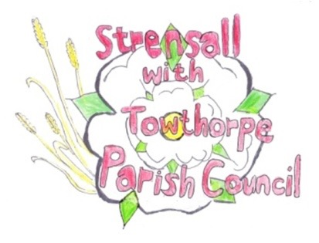
STRENSALL WITH TOWTHORPE PARISH COUNCIL The Village Hall, Northfields, Strensall, York YO325XW e-mail: strensalltowthorpePC@outlook.com phone: 01904 491569

MINUTES OF A PLANNING COMMITTEE MEETING HELD ON TUESDAY 14TH JANUARY 2025 AT 6.30P.M.
Councillors Present: Andrew Bolton Chris Chambers Tony Fisher Graham Green Lawrence Mattinson
In Attendance: Fiona Hill - Parish Clerk
Public Present: 5
- a) To receive apologies for absence given in advance of the meeting: None
b) To consider the approval of reasons given for absence: N/A

- To receive any declarations of interest under the Parish Council Code of Conduct or
Members register of interests:
Cllr Fisher advised that he had a non-pecuniary interest as he knows both the applicant and the complainant.

- To approve the minutes of the Planning Committee meeting of 12th November 2024:
(The meetings on 26th November 2024 and 10th December 2024 were cancelled)
Resolved / Approved (Unanimous)

- To discuss any ongoing issues and information received:

- To consider and respond to consultations from City of York Council to the planning a applications as follows: 24/02241/FUL - Construction of 7no. Fishers bedroom lodges, separate shower block with combined office, formation of vehicle access and installation of 10no. car
parking spaces @ Potteries Lake, Pottery Lane
Resolved / Objection (Unanimous)
- The development would damage the amenity of the adjacent residential property
- The development would affect the openness of the greenbelt
- The development would cause further conflict of users of Pottery Lane
- The development will create a hazard for disposal of foul water and sewage. If the application was to be approved, then all foul water and sewage should be removed from site.
- There is no electricity on site and the application includes an office site and a sewage treatment site. No generators should be allowed on site.
- The biodiversity net gain report should be prepared based on the original site, not after the habitat destruction recent done.

- To note planning decisions received: a) 24/01693/TCA - Fell 2no. (diseased) Alders and remove deadwood from 2no.
Alders - trees in a conservation area @ Tree Tops 1B The Village Strensall - Consented
b) 24/01724/TCA - Crown reduce 1no. Hawthorn Tree up to 3.6m (T1); Crown reduce up to 1.8 meters and dead wood removal from 1no. Apple (T2) ; Crown reduce up to 1.8 meters 1no. Plum (T3); General prune to encourage fruit production and for maintenance of 1no. Apple (T4); Up to 2.4m reduction of 1no. Ash tree (T5); Crown reduction up to 2.4m of 1no. Wild Cherry (T6); Reduction of Leylandii Hedge (G1) - trees in a conservation area @ 113 The Village Strensall - Consented
c) 24/01725/TCA - Reduce 2no. Plum trees (T7, T8) up to 2.4m to formalise and contain growth - trees in a conservation area @ 115 The Village Strensall – Consented
d) 24/01798/TCA - 2.4m crown reduction and up to 1.8m lateral reduction of 1no. Crab Apple - tree in a conservation area @ 16 The Village – Consented
e) 24/01806/TCA - Crown reduce 1no. Ash 2.4m in height and 1.8m laterally and cut back branches of fruit trees (TG1) that overhang 123 The Village - trees in a conservation area @ 125 The Village – Consented
f) 24/01936/TCA - Silvicultural thin of woodland involving the felling of 11no. Norwegian Spruce (of which four are already dead) and plant at least 6 native trees and reestablish native hedge on eastern boundary - trees in a conservation area @ Land Adjacent The Garth, Southfields Road – No Objections

23/182 To confirm date of the next meeting on Tuesday 28th January 2025 @ 6.30 p.m. Resolved / Approved (Unanimous)

