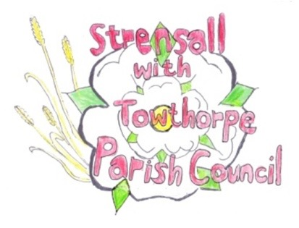
STRENSALL WITH TOWTHORPE PARISH COUNCIL The Village Hall, Northfields, Strensall, York YO325XW Email: strensalltowthorpePC@outlook.com Telephone: 01904 491569

MINUTES OF A PLANNING COMMITTEE MEETING HELD ON TUESDAY 14th OCTOBER 2025 AT 6.30P.M.

Councillors Present: Andrew Bolton Thomas Carmicheal Chris Chambers Tony Fisher Graham Green Lawrence Mattinson
In Attendance: Fiona Hill - Parish Clerk
Public Present: 1 – David Dale

- a) To receive apologies for absence given in advance of the meeting: None
b) To consider the approval of reasons given for absence: N/A
- To receive any declarations of interest under the Parish Council Code of Conduct or
Members register of interests: None

- To approve the minutes of the Planning Committee meeting of 23rd September 2025:
Resolved / Approved (Unanimous)

- To discuss any ongoing issues and information received: None

- To consider and respond to consultations from City of York Council to the planning a applications as follows:

- 25/01684/FUL - First floor rear extension @ 1 Firbank Close
Resolved / Neutral, No Objections (Unanimous)

- 25/01858/FUL - First floor side extension @ 6 Coulson Close
Resolved / Neutral, No Objections (Unanimous)

- 25/01935/TCA - Reduce Leylandii group to 3-4m above ground level - trees in a conservation area @ Grange Hill 61 The Village
Resolved / Neutral, No Objections (Unanimous)

- To note planning decisions received:
- 25/01458/TPO - Reduce the branch work extending into garden by approximately 2.4 meters and removal of one damaged limb of 1no. Oak protected by Tree Preservation Order CYC 285 @ 16 Heath Ride – No Objections

- 25/01488/FUL - Pitched roof to existing garage, conversion of detached garage to habitable space, timber fence to boundary perimeter and new access driveway gates @ 4 Newton Way - Householder Approval

- 25/01656/TCA - Fell 1no. Christmas tree (rear garden) - tree in a conservation area @ The Coach House Southfields Road - Consented

- To confirm date of the next meeting on Tuesday 28th October 2025 @ 6.30 p.m. Resolved / Approved (Unanimous)

