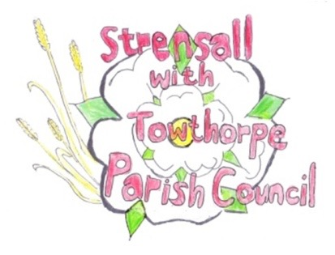
STRENSALL WITH TOWTHORPE PARISH COUNCIL The Village Hall, Northfields, Strensall, York YO325XW Email: strensalltowthorpePC@outlook.com Telephone: 01904 491569

MINUTES OF A PLANNING COMMITTEE MEETING HELD ON TUESDAY 23th SEPTEMBER 2025 AT 6.30P.M.

Councillors Present: Andrew Bolton Chris Chambers Graham Green
In Attendance: Fiona Hill - Parish Clerk
Public Present: 0

- a) To receive apologies for absence given in advance of the meeting: Thomas Carmicheal and Lawrence Mattinson
b) To consider the approval of reasons given for absence: Resolved / Approved (Unanimous)

- To receive any declarations of interest under the Parish Council Code of Conduct or
Members register of interests: None

- To approve the minutes of the Planning Committee meeting of 09th September 2025:
Resolved / Approved (Unanimous)

- To discuss any ongoing issues and information received: None

- To consider and respond to consultations from City of York Council to the planning a applications as follows: a) 25/01689/FUL – Single storey rear extension and first floor side extension with rear dormer @ 10 Church lane Resolved / Neutral, the architectural design will not enhance the street scene (Unanimous)

- To note planning decisions received: a) 25/01424/FUL – Single storey side and rear extension @ 68 Barley Rise – Approved

- To confirm date of the next meeting on Tuesday 14th October 2025 @ 6.30 p.m. Resolved / Approved (Unanimous)

