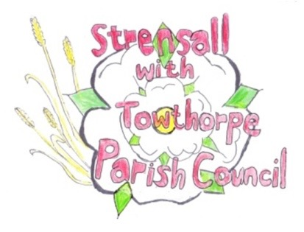
STRENSALL WITH TOWTHORPE PARISH COUNCIL The Village Hall, Northfields, Strensall, York YO325XW Email: strensalltowthorpePC@outlook.com Telephone: 01904 491569

MINUTES OF A PLANNING COMMITTEE MEETING HELD ON TUESDAY 27th MAY 2025 AT 6.30P.M.
Councillors Present: Andrew Bolton Tony Fisher Graham Green Lawrence Mattinson
In Attendance: Fiona Hill - Parish Clerk
Public Present: 0
- a) To receive apologies for absence given in advance of the meeting:
Thomas Carmicheal and Chris Chambers
b) To consider the approval of reasons given for absence:
Resolved / Approved (Unanimous)

- To receive any declarations of interest under the Parish Council Code of Conduct or
Members register of interests: None

- To approve the minutes of the Planning Committee meeting of 13th May 2025:
Resolved / Approved (Unanimous)

- To discuss any ongoing issues and information received: None

- To consider and respond to consultations from City of York Council to the planning a applications as follows:

- 25/00220/FUL – Replacement conservatory to rear @ 22 Westpit Lane
Resolved / Neutral. No Objection

- 25/00878/FUL – Two storey side extension, render, portico and alterations to windows to front after removal of porches to front and side @ 33 Southfields Road
Resolved / Neutral. No Objection

- 25/00910/FUL – Replacement of existing open steel mesh gates to the south porch of church with new high quality oak and glass doors @ St Mary’s Church, Church Lane
Resolved / Neutral. No Objection, however it would be regrettable to not retain
The internal doors. Has it been considered if they can be kept in situ in a fold
Back manner, allowing the new doors to open/shut alongside.

- 25/00931/FUL – Single storey side and rear extension, porch to front, replacement windows and render and re-cladding of existing dormers @ 4 Moorland Garth
Resolved / Neutral. No Objection

- To note planning decisions received: 25/00577/TCA – Fell 1no. Pear tree in a Conservation Area @ 101 The Village - Consented

- To confirm date of the next meeting on Tuesday 10th June2025 @ 6.30 p.m.
Resolved / Approved (Unanimous)

