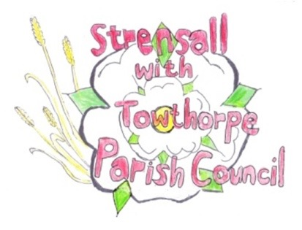
STRENSALL WITH TOWTHORPE PARISH COUNCIL The Village Hall, Northfields, Strensall, York YO325XW Email: strensalltowthorpePC@outlook.com Telephone: 01904 491569

MINUTES OF A PLANNING COMMITTEE MEETING HELD ON TUESDAY 28th OCTOBER 2025 AT 6.30P.M.

Councillors Present: Andrew Bolton Chris Chambers Tony Fisher Graham Green
In Attendance: Fiona Hill - Parish Clerk
Public Present: 0

The Planning Committee observed a minute’s silence in memory of Parish Councillor Susan Nunn

- a) To receive apologies for absence given in advance of the meeting:
Thomas Carmicheal
b) To consider the approval of reasons given for absence: Resolved / Approved (Unanimous)

- To receive any declarations of interest under the Parish Council Code of Conduct or
Members register of interests: None

- To approve the minutes of the Planning Committee meeting of 14rd October 2025:
Resolved / Approved (Unanimous)

- To discuss any ongoing issues and information received: None

- To consider and respond to consultations from City of York Council to the planning a applications as follows:

- 25/01906/FUL - Two storey side and rear extension and single storey rear extension @ 17 Wood Close
Resolved – Objection – This is an over-development of the site and would impact the amenity of the residents of Number 19. If minded to approve the application, it should be conditioned that the flat roof cannot be accessed from the house/become an occupiable space. (Unanimous)

- 25/02020/TCA - Fell 1no. Spruce (rear gdn) - tree in a conservation area @ The Stables, 70 The Village
Resolved – Neutral – No Objection, but the Parish Council would request a suitable tree be planted in the garden (Unanimous)

- To note planning decisions received:
a) 25/01536/TCA - Remove large branch overhanging 61 The Village from 1no. Ash (located at 67 The Village) - tree in a conservation area @ Aleppo, 67 The Village – Consented
b) 25/01656/TCA - Fell 1no. Christmas tree (rear garden) - tree in a conservation area @ The Coach House, Southfields Road - Consented
c) 25/01640/FUL - Single storey rear extension @ 15 Littlethorpe Close – Approved
d) 25/01713/TCA - Fell 1no. Silver Birch (rear gdn) - tree in a conservation area @ The Stables, 70 The Village - Consented

- To confirm date of the next meeting on Tuesday 11th November 2025 @ 6.30 p.m. Resolved / Approved (Unanimous)

