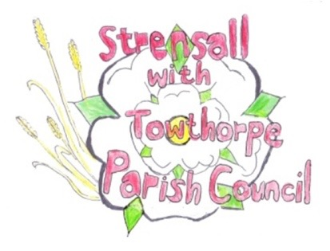
STRENSALL WITH TOWTHORPE PARISH COUNCIL
The Village Hall, Northfields, Strensall, York YO325XW
e-mail: strensalltowthorpePC@outlook.com phone: 01904 491569

NOTICE is hereby given that there will be a Planning Committee meeting of The Parish Council Planning Committee on Tuesday 10th February 2026 at 6.30pm to be held in the Village Hall for the purpose of transacting the business shown on the Agenda below.
Members of the public and press are welcome to attend
Members of the Council are hereby summoned to attend

AGENDA

1. a) To receive apologies for absence given in advance of the meeting:
b) To consider the approval of reasons given for absence:

2. To receive any declarations of interest under the Parish Council Code of Conduct and Register of Interests

3. To approve the Minutes of 13th January 2026 (Meeting Cancelled – 27th January 2026)

4. To discuss any ongoing issues and information received:

5. To consider and respond to consultations from City of York Council to the planning applications as follows:

- 26/00140/FUL - Single storey extension to front @ 34 Kirklands
- 26/00142/FUL - Single storey rear extension with first floor rear balcony @ Lawnswood, Southfields Road
- 26/00147/TCA – Fell 1no. Goat Willow tree in a Conservation Area @ Montana, 18 York Road
- 26/00150/FUL - Single storey rear extension @ 4 Heath Ride

6. To note planning decisions received:

- 25/02114/TPO - Crown lift to 3m above ground level of 1no. Oak protected by Tree Preservation Order CYC 30 @ 6 Brunswick Close – No Objections
- 25/02320/TCA - Up to 2.4m crown reduction of 1no. Beech (rear gdn) - tree in a conservation area @ 11 Moor Lane - Consented
- 25/02361/FUL - Single storey rear extension @ 36 Moor Lane - Approval
- 25/02404/TCA - Draw back branches of Oak by up to 1.5m to give 2m clearance when tree in leaf - tree in a Conservation Area @ 103 The Village - Consented

7. To confirm the date of the next meeting: - 24th February 2026 at 6.30pm

Fiona Hill - Clerk to the Parish Council 04th February 2026

