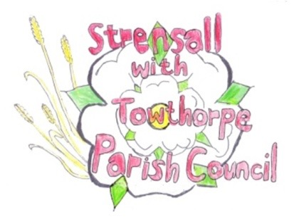
STRENSALL WITH TOWTHORPE PARISH COUNCIL
The Village Hall, Northfields, Strensall, York YO325XW
e-mail: strensalltowthorpePC@outlook.com phone: 01904 491569

MINUTES OF A PLANNING COMMITTEE MEETING HELD ON TUESDAY 23th June 2026 AT 6.30P.M.

Councillors Present: Andrew Bolton Graham Green
Thomas Carmicheal Tony Fisher

In Attendance: Carrie Pillow – Locum (who partially prepared minutes)

Public Present: 0

1. a) To receive apologies for absence given in advance of the meeting: None
b) To consider the approval of reasons given for absence: N/A

2. To receive any declarations of interest under the Parish Council Code of Conduct and Register of Interests
No Precunary or None Precunary interests, noted Cllr Green is a Neighbour of applicant for 26/01022/FUL

3. To approve the Minutes of 26th May 2026 (Meeting 09th June 2026 cancelled)
Minutes approved, to be signed at next meeting.

4. To discuss any ongoing issues and information received:
City of York Council have advised the Parish Council that an appeal has been lodged against an enforcement notice - 6 the village enforcement notice. The grounds for the appeal are the timescales given to rectify the situation. The Parish council agreed not to get involved

5. To consider and respond to consultations from City of York Council to the planning applications as follows:

- 26/00748/FUL - Replacement windows throughout @ 60 The Village
No Objection
- 26/01006/FUL - Porch to front and landscaping alterations @ Forest Hill Farm Pottery Lane
No Objection
- 26/01022/FUL - First floor extension to create additional storey and other elevational alterations @ Birchlands, Lords Moor Lane
The Parish Council object to this application due to it being out of character with the local street scene, as defined in the approved neighbourhood plan and the Village Design Statement. The flat roofed contemporary design proposed contravenes Policy DH2 of the adopted Neighbourhood Plan.
It should be noted that other contemporary planning applications on Lords Moor Lane (Demolition and New Build) that are fully visible & prominent in the street scene were approved before the legal and binding adoption of the Neighbourhood Plan. Therefore any perceived precedence, particularly with regard to the Flat Roof is rendered null & void.
The more recent flat roofed contemporary new build approval (24/01670) will not be visible in the street scene as it will be set back and built in the rear garden behind an existing large property. Therefore there can be no precedence argument for another Flat roofed contemporary dwelling, based on this planning application

- 26/01041/FUL - Change of use of land from agricultural use to the siting of 73 no. external storage containers (Use Class B8) – retrospective @ BHE Self Storage Self Storage Facility, Lambshill, Towthorpe Moor
The Parish Council object to this application for the same reasons as specified in applications 22/01032/FUL, 23/02117/FUL and the appeal 24/00018/REF. There are no very special circumstances that outweigh the harm to the Green Belt as confirmed by HM Inspector in the Decision Notice for Appeal Ref: APP/C2741/W/24/3342868

6. To note planning decisions received:
26/00756/TCA - Fell 1no. Apple tree in a Conservation Area @ 20 The Village - Consented
Noted

7. To confirm the date of the next meeting: - 14th July 2026 at 6.30pm
Noted

