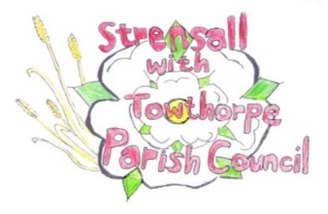
STRENSALL WITH TOWTHORPE PARISH COUNCIL
The Village Hall, Northfields, Strensall, York YO325XW
e-mail: strensalltowthorpePC@outlook.com
phone: 01904 491569
Chairman : Mr A H Fisher

MINUTES OF AN PARISH COUNCIL MEETING HELD IN THE VILLAGE HALL ON TUESDAY 14th JULY 2026 AT 7.00 PM
Councillors Present: Andrew Bolton Thomas Carmicheal Chris Chambers Anthony Drake Tony Fisher¹ Sarah Glynn Graham Green Simon Hide Daniel Pillai
In Attendance: Fiona Hill – Parish Clerk

Public Present: 1
¹ City of York Councillor
25/350 a) To receive apologies for absence given in advance of the meeting: Lawrence Mattinson and Alan May b) To consider the approval of reasons given for absence: Resolved / Approved (Unanimous)
25/351 To discuss the casual vacancy: Nothing to report

25/352To receive any declarations of interest under the Parish Council Code of Conduct or
Members register of interests: None
25/353 a) To approve the minutes of the Parish Council meeting of 12th May 2026: Resolved / Approved (Unanimous) b) To endorse the approved Planning Committee minutes of 12th and 26th May 2026 and 23rd June 2026: Resolved / Endorsed (Unanimous)
25/354 Public participation on any subject relating to the agenda: None
25/355To receive matters raised by/with City of York Ward Councillors: Cllr Fisher – - reported on the issues experienced with Irish travelers in Haxby - reported that he had received a number of complaints about the recently erected fence on the permissive footpath, but the landowner is legally allowed to do this. - advised that the inspectors report from the recent public inquiry was expected in about six months. - advised that the farmers cart is outside of this parish, so no comment will be made by this Parish Council.
25/356 To discus matters raised by/with Yorkshire Local Councils Association (YLCA) Nothing to report
25/357 To discuss and, if necessary, agree action on matters arising/ongoing issues: a) North Yorkshire Police monthly reports – June 2026 report received
b) Community Memorial Garden CYC – Progress on land transfer / lease – Kitty Lee-Macfarlane, Junior Property Surveyor, CYC had emailed – “As the land we will be leasing to the Parish Council is designated Public Open Space we have to go through the process of serving a Section 123 Notice, this means CYC must advertise the loss of Public Open Space in the local paper for a minimum of two weeks to make the general public aware and allow them to submit any concerns or comments they may have. I am currently going through this process with our legal team and will be back in touch regarding the lease terms once it is complete”.
c) Play Areas – Handyman inspections The handyman had cleaned the play area equipment using the Parish Council pressure washer and cut back the overgrown vegetation along the Lords Moor Lane – Moor Lane footpath.
25/358 To discuss and, if necessary, agree action, on matters raised since last meetings: a) Barnes Associates – Trees Assessment 2026 The Parish Clerk had circulated the report along with a table of works required within 3 months, 6 months, 12 months, 18 months. Resolved / The Parish Clerk would immediately obtain quotes for the work required with 3 and 6 months (Unanimous) Resolved / The Parish Clerk would in July 2027 obtain quotes for the work required with 12 and 18 months (Unanimous)
25/359 To discuss matters raised by/with Parish Clerk/Responsible Financial Officer (RFO): a) Financial Management - Bank reconciliation, receipts and payments to date: Parish Clerk had circulated reports below, which covers the period 01 April 2026 – 30 June 2026. The income/expenditure during this period is within budget. The updated ring-fenced and earmarked funding is shown. The Skipton Building Society account is now open.

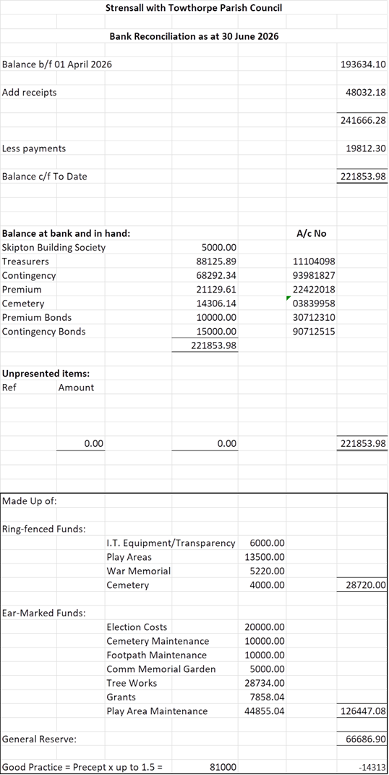

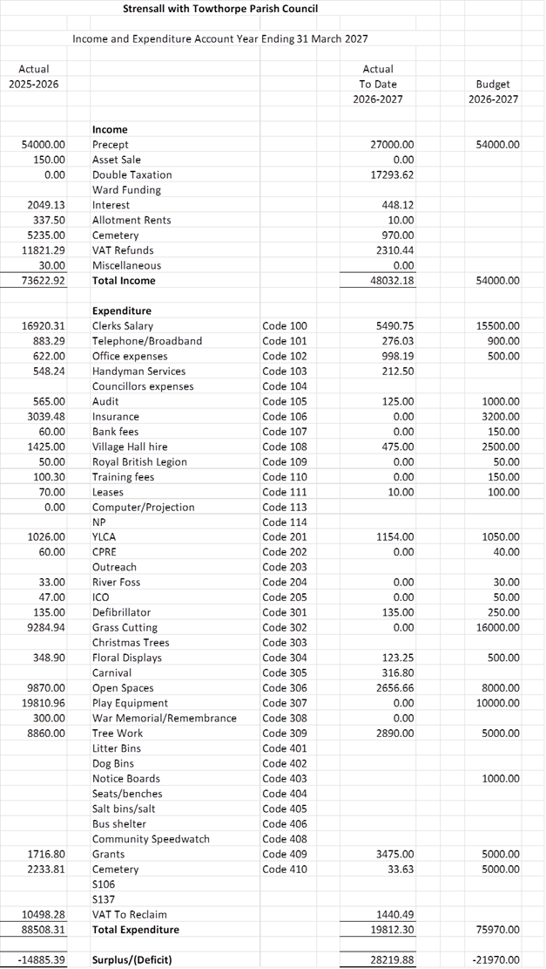

Financial Management - Payment Approval: None Financial Management – Internal Controls: Cllr Fisher would conduct these in the office tomorrow.
b) Policy Review: The Parish Clerk had emailed Cllrs as follows: “At the Annual Parish Council Meeting, I reported that a complete policy review would be conducted. I have attached a copy of the YLCA Checklist for information. I will deal with them in sections as follows: July 2026 - Council Management, Environment, Buildings & Facilities August 2026 - Play Areas, Burial Authorities, Allotments September 2026 - Openness & accountability, Communications October 2026 - Financial, Employment & Personnel November 2026 - Basic Governance
Council Management: SR/AR/CR - None BP - No policies necessary. CYC Parish Charter attached for information. List of passwords held in an ewallet.
Environment: SR/AR/CR - As CYC own/manage the dog waste bins within the parish the PC does not require a Certificate of waste disposal. BP - The PC has a Trees Policy, which will be added to website. The Parish Map can be using the City of York Council website mapping system
Buildings & Facilities: SR/AR/CR - The PC does not own/manage any buildings, so no policies required BP - The PC does not own/manage any buildings, so no policies required
c) Website renewal: The current website hosting is valid until December 2026 and the domain is valid until February 2028, however, it is now urgently required that quotes are obtained for a new Gov.UK website , so the Parish Clerk would get on with this.
d) Monthly Report from Parish Office: The Parish Clerk had checked back through minutes January – June 2026 and there are three outstanding issues: - Wilkinson, Cobb & Hodgson Trust – the trust wrote asking the Parish Council to nominate up to three members. At a previous meeting Cllr Carmicheal was nominated, but there are two more vacancies should a Cllr be interested. - Traffic study and proposals – no response had been received, other than the acknowledgment of receipt, so the Parish Clerk would chase this up. - Fence/Langton Court – the contractor was instructed to delay the work until after the bird nesting season, so as this was coming to an end, the Parish Clerk would obtain a start date.
25/360 To confirm the date of the next meeting as Tuesday 10th August 2026 at 7.00 p.m. Resolved / Approved (Unanimous)

