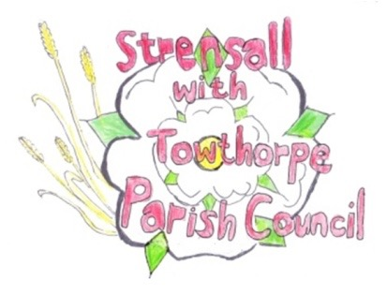
STRENSALL WITH TOWTHORPE PARISH COUNCIL The Village Hall, Northfields, Strensall, York YO325XW Email: strensalltowthorpePC@outlook.com Telephone: 01904 491569

MINUTES OF A PLANNING COMMITTEE MEETING HELD ON TUESDAY 14th JULY 2026 AT 6.30P.M.
Councillors Present: Andrew Bolton Thomas Carmicheal Chris Chambers Tony Fisher Graham Green
In Attendance: Fiona Hill - Parish Clerk
Public Present: 1
- a) To receive apologies for absence given in advance of the meeting:
Lawrence Mattinson
b) To consider the approval of reasons given for absence:
Resolved / Approved (Unanimous)

- To receive any declarations of interest under the Parish Council Code of Conduct or
Members register of interests: None

- To approve the minutes of the Planning Committee meeting of 23rd June 2026:
Resolved / Approved (Unanimous)

- To discuss any ongoing issues and information received: None

- To consider and respond to consultations from City of York Council to the planning applications as follows: a) 26/01039/FUL – Variation of condition 1 of permitted application 22/00052/FUL to vary the opening hours @ Strensall Camp Service Station, 605 Strensall Road Resolved / No Objection (Unanimous) but would suggest that on Sundays the opening hour remains at 0700.

b) 26/01170/FUL – Single storey rear extension and replacement roof to existing rear extension @ Plum Tree House, 3 Moor Lane Resolved / No Objection (Unanimous)

- To note planning decisions received: a) 26/00609/FUL – Single storey side extension, dormers to front and rear roof slopes and
front porch @ 15 Moorland Garth – Approved

b) 26/00846/FUL – Two storey side and rear extension @ 10 Church Lane - Refused

- To confirm date of the next meeting on Tuesday 28th July 2026 @ 6.30 p.m. Resolved / Approved (Unanimous)

