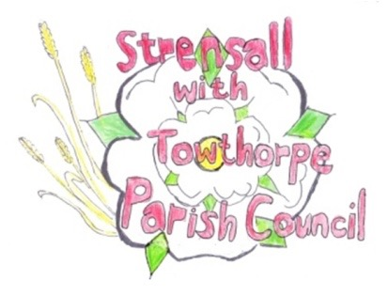
STRENSALL WITH TOWTHORPE PARISH COUNCIL The Village Hall, Northfields, Strensall, York YO325XW Email: strensalltowthorpePC@outlook.com Telephone: 01904 491569
MINUTES OF A PLANNING COMMITTEE MEETING HELD ON TUESDAY 11th AUGUST 2026 AT 6.30P.M.
Councillors Present: Andrew Bolton Thomas Carmicheal Chris Chambers Tony Fisher Graham Green
In Attendance: Fiona Hill - Parish Clerk
Public Present: 1
- a) To receive apologies for absence given in advance of the meeting:
Lawrence Mattinson
b) To consider the approval of reasons given for absence:
Resolved / Approved (Unanimous)

- To receive any declarations of interest under the Parish Council Code of Conduct or
Members register of interests: None

- To approve the minutes of the Planning Committee meeting of 14th July 2026:
Resolved / Approved (Unanimous)

- To discuss any ongoing issues and information received: None

- To consider and respond to consultations from City of York Council to the planning applications as follows:
- 26/01314/FUL - Single storey side extension @ 18 Westpit Lane
Resolved / No Objections (Unanimous)
- 26/01341/FUL - Installation of air source heat pump to side @ 6 Leyfield Close
Resolved / Objection, based on the failed noise survey, either an alternative heat pump that passes the noise survey or a more suitable location, should be found, away from neighbouring properties. (Unanimous)
- 26/01408/FUL - Detached garage to side @ 35 Riverside Walk
Resolved / No Objections (Unanimous)
- 26/01414/FUL - Single storey side extension and 1.8 metre fence to boundary @ 34 Barley Rise
Resolved / No Objections (Unanimous)

- To note planning decisions received:
- 26/00748/FUL - Replacement windows and patio doors throughout (part retrospective) @ 60 The Village - Approved
- 26/00756/TCA - Fell 1no. Apple tree in a Conservation Area @ 20 The Village – Consented
- 26/00807/FUL - Erection of office/shower block and 10no. fishing lodges and new parking provisions @ Potteries Lake, Pottery Lane - Refused
- 26/01006/FUL - Porch to front and new parking area @ Forest Hill Farm, Pottery Lane – Approved
- 26/01022/FUL - First floor extension to create additional storey and other elevational alterations @ Birchlands, Lords Moor Lane – Approved

27/7 To confirm date of the next meeting on Tuesday 25th August 2026 @ 6.30 p.m. Resolved / Approved (Unanimous)

